Autogyro UAV

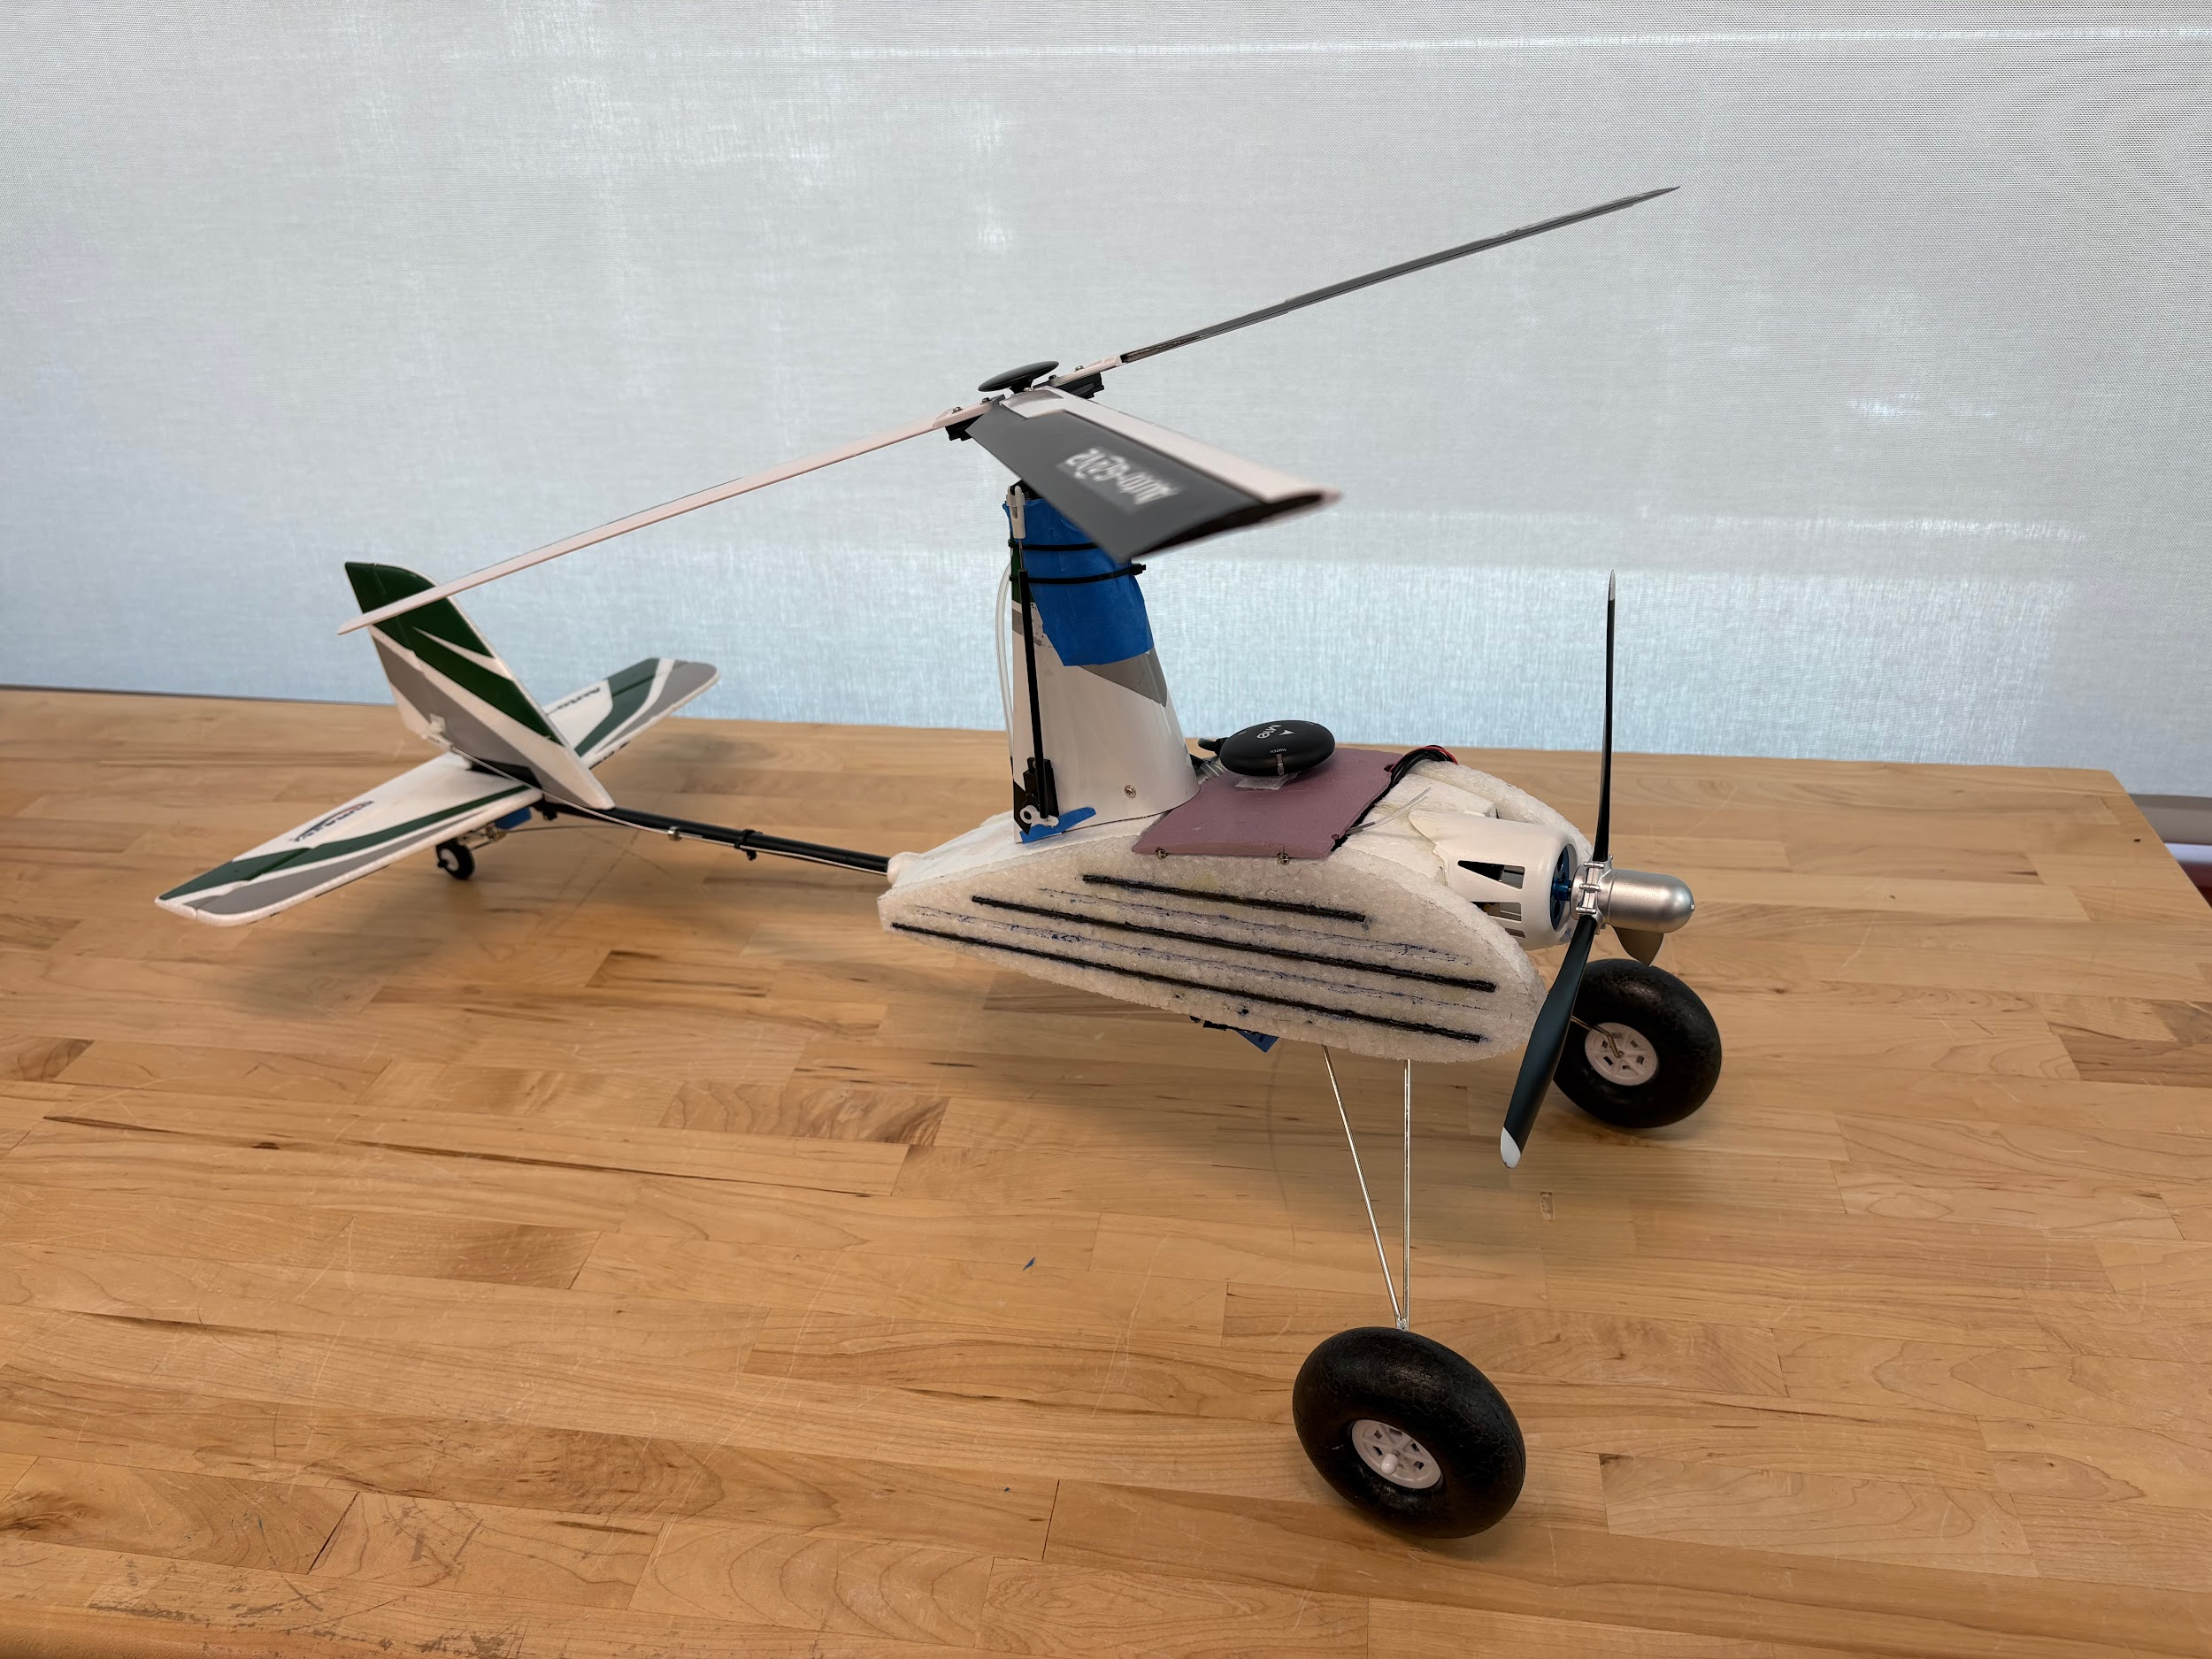

Ruochen Li, Arham Nawaf, Pranav Sakhuja, Aaditya Shivadey

MAE 156B- Fundamental Principles of Mechanical Design II

University of California San Diego

Instructor: Dr. Jerry Tustaniwskyj, UC San Diego MAE

Sponsor: Dr. Robert Heath, UC San Diego ECE

Date: June 10, 2025

# **Table of Contents**

Table of Contents 2

**Executive Summary 4**

**Abstract 5**

**List of Tables 8**

**Chapter 1: Project Description 9**

Background 9

Review of Existing Design Solutions 11

Statement of Requirements 12

Project Deliverables 14

**Chapter 2: Description of Final Design Solution** 14

Mechanical Architecture 16

Electronics Architecture 17

**Chapter 3: Design of Key Components** 21

Fuselage 21

Fuselage Manufacturing Procedure 26

Rear Landing Gear Mount 28

Camera Mount 31

**Chapter 4: Prototype Performance 33**

Fluid Simulations: 34

Stress Simulations Of Fuselage Panels: 35

Camera Mount Performance 37

Video Streaming 38

Computer Vision Processing 39

Flight Log Analysis 41

**Chapter 5: Design Recommendations 42**

**Conclusion 43**

Impact on Society 43

Professional Responsibility 44

Applicable Standards 45

**Acknowledgements 48**

References 49

Appendix 49

Appendix A: Individual Component Analysis - Ease Of Modifications For Potential AutoGyro Options (Arham Nawaf) 50

Appendix B: Individual Component Analysis: Camera and Streaming System (Ruochen Li) 59

Appendix C: Individual Component Analysis - Flight Controller (Pranav Sakhuja) 64

Appendix D: Individual Component Analysis - Payload Capacity of Autogyros (Aaditya Shivadey) 71

Code Used 77

Project Management 81

Task Distribution 81

Risk Reduction Effort 81

Intermediate deadlines 82

Layouts 82

List of Suppliers / Purchased Part Information 83

Designs Considered 84

Equations and Formulas Used 84

Calculations 84

Budget 84

# 

# **Executive Summary**

The autogyro is a class of aircraft that relies on the lift generated by the autorotation of its singular vertical axis unpowered rotor as its front mounted propeller generates horizontal thrust.

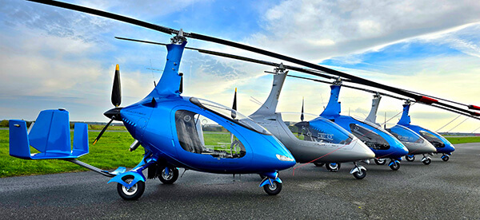

Figure 1.1: Modern Autogyros, as developed by AutoGyro USA   
*AutoGyro USA*, [https://Autogyrousa.com](https://autogyrousa.com/models/mtosport-2017/)

Traditional quadcopter and octocopter drones are loud and energy inefficient. The objective of the project was to determine the feasibility of the autogyro aircraft in surveillance projects due to its low energy consumption, autorotation-based propulsion, and safer descent during power failure.

This project aimed to develop an autonomous autogyro based on the Durafly Autofly G2 V2 for surveillance on Scripps Pier such that it is able to stream live video to a Ground Control Station. To achieve this, multiple iterations of Extruded Polystyrene (XPS) and Expanded Polypropylene Foam (EPP) based fuselages were developed to accommodate the autonomous flight control and camera hardware. Finally, a widened carbon fiber rod-reinforced EPP foam fuselage was manufactured due to its desirable mechanical characteristics over other previously mentioned alternatives.

Based on the project sponsor’s requirements, the developed autogyro must be capable of streaming live video feed for surveillance of the wave conditions at Scripps Pier and shark watch. Furthermore, the sponsor suggested that the autogyro should have the capability to allow for future autonomy integration capability. Hence, in addition to the battery, the payload consisted of a flight controller, a receiver, camera PCB, telemetry transmitter, and a GPS module.

# **Abstract**

This project developed an autogyro Unmanned Aerial Vehicle (UAV) as a safer and more energy efficient alternative to traditional quadcopters for coastal monitoring. Unlike drones that use multiple motors for lift, autogyros rely on an unpowered spinning rotor for lift and a front propeller for thrust, allowing a safer descent during power failure. The end-goal for the sponsor was to explore an autogyro UAV that can fly a path over Scripps Pier in La Jolla, stream live video, and potentially detect sharks using onboard cameras. Off-the-shelf autogyro kits are only built for manual control and lack space for extra electronics like flight controllers and GPS. To solve this problem, the team redesigned the fuselage to house all components, integrated a camera system, and set up a ground control system for autonomous flight. The final design demonstrates stable manual flight with autopilot integrability, real-time video streaming and safer emergency descent.

# List of Figures

Figure 1.1**:** Modern Autogyros, as developed by AutoGyro USA 4

Figure 1.2 Lift generation in an Autogyro 8

Figure 1.3 Thunderfly TF-G1 unmanned Autogyro 11

Figure 2.1 (a): Holybro Pixhawk 6c Mini (b): DJI Goggles N3 + O4 Unit 16

Figure 2.2 Fully assembled Autogyro 17

Figure 2.3 Electronics System Architecture 18

Figure 2.4 Camera Streaming System Architecture 19

Figure 3.1 Original Mounting Geometry and Relative Component Locations 21

Figure 3.2 Fuselage Design Option 1 22

Figure 3.3 Fuselage Design Option 2 23

Figure 3.4 XPS Panel Brittle Failure 24

Figure 3.5 Composite panel CAD model 25

Figure 3.6 Composite panels on autogyro 25

Figure 3.7 Fuselage cut lines  26

Figure 3.8 C clamp mount 28

Figure 3.9 Rear landing gear mount option 2 CAD 29

Figure 3.10 Option 2 mount assembled 29

Figure 3.11 Fixed Mount CAD Model 31

Figure 3.12 Gimbal CAD Model 31

Figure 4.1 CFD Simulations Original Fuselage 34

Figure 4.2 CFD Simulation Enlarged fuselage 35

Figure 4.3 XPS Panel FEA 35

Figure 4.4 Composite Panel FEA 35

Figure 4.5 XPS Panel Impact Test 36

Figure 4.6 Composite Panel Impact Test 36

Figure 4.7 In-flight Footage Captured from Fixed Camera Mount 37

Figure 4.8 Live Stream on Twitch Channel (@uavAutogyro) 38

Figure 4.9 Preliminary YOLOv8x Inference Result (confidence scores shown) 39

Figure 4.10 Actuator commands from PX4 flight log 41

# 

# **List of Tables**

Table 1: Project Requirements 12

Table 2: Fuselage Design Options Pros and Cons 25

Table 3: Rear Landing Gear Mount Design Options Pros and Cons 30

# Chapter 1: Project Description

## **Background**

In recent years, unmanned aerial drones have increasingly been used in the fields of videography, photography, and surveillance in addition to many others. However, typical quadcopter/octocopter drones need at least 4-8 separate rotors to be powered with motors. This renders them expensive to make and maintain as well as energy inefficient. Furthermore, in case of complete power failure, traditional drones have the tendency to plummet to the ground instead of descending safely without causing public safety issues. This motivates the need to explore autogyros as an unmanned aerial vehicle (UAV) that is capable of surveilling any area of interest.

An autogyro, frequently also referred to as a gyrocopter, is an aircraft class that consists of an unpowered rotor, and a powered front propeller. As seen in Figure 1.2, it utilizes the lift produced by the autorotation of its rotor blades and mostly relies on its front propeller for horizontal propulsion. The autorotation of the rotor provides a consistent lift without the need for using a vertical propulsion method like traditional drones. Hence, autogyros are often capable of taking off and landing on fairly short runways. Additionally, unlike fixed wing aircraft, autogyros do not exhibit typical stalling behavior in case of a power loss to the driving propeller/engine due to autorotation of its rotor.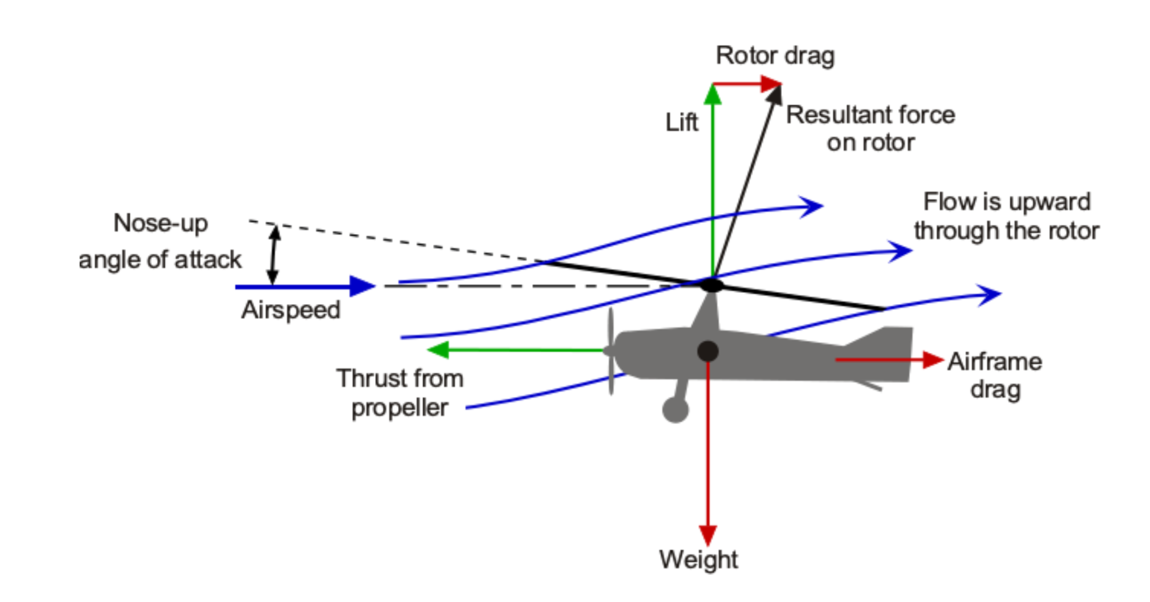

Figure 1.2 Lift generation in an Autogyro. *Reproduced from* “Autogiros and Gyroplanes,” in *Introduction to Aerospace Flight Vehicles*, Embry-Riddle Aeronautical University, <https://eaglepubs.erau.edu/introductiontoaerospaceflightvehicles/chapter/autogiros-and-gyroplanes/>.

This report presents a version of an autogyro UAV capable of autonomous flight characteristics and video surveillance of the Scripps Pier in La Jolla, CA to monitor the live wave and weather conditions and also to capable of detecting any sharks in the surveilled areas, as requested by the principal investigator and sponsor, Dr. Robert Heath. Dr. Heath is a Professor of Electrical and Computer Engineering at UC San Diego, and his research specializes in Multiple-Input Multiple-Output (MIMO) wireless communications. This project was in the intersection of his academic research and hobbyist interest in flying planes. His hypothesis behind pursuing this project was that autogyros might be able to provide an energy efficient and safer alternative to traditional quad/octocopter drones for surveillance, especially in areas where winds can be harnessed for generating lift, like at the Scripps Pier.

## **Review of Existing Design Solutions**

Existing solutions for monitoring purposes in scientific research are quadcopter and octocopter drones as previously mentioned. However, those drones are extremely energy inefficient and noisy, due to the presence of 4-8 motors that need to be powered throughout the flight. Hence, alternate aircraft classes UAVs need to be explored to allow for more efficient, quieter, and safer flights for the purpose of surveillance and hobbyist flying.

There are autogyro kits available on the market like the Rainbow Autogyro [1] which can be purchased and built for flying. However, those options are meant for hobby flying with manual control via Remote Control (RC). To enable autonomous flight along a predetermined path, a flight controller compatible with an autopilot firmware stack is required within the UAV. Furthermore, these autogyros do not come with a camera/video streaming system which is essential for live monitoring of the La Jolla shoreline. Additionally, all autogyro options on the market have small fuselages meant to house a battery, electronic speed controller (ESC), and receiver. Thus, the addition of more electronics hardware such as a flight controller, global positioning system (GPS), and camera requires a larger fuselage capable of storing these components during flight. No available autogyro on the market had the option of such an enlarged fuselage.

One existing autogyro monitoring solution with autopilot and camera capabilities has been implemented by a company known as Thunderfly [2], a company based in the Czech Republic, and the team contacted them to gain additional information about their product offerings. Thunderfly informed the team that their autogyros are designed as advanced platforms for carrying industrial scale scientific instruments for collecting data and performing experiments and hence will not be suitable for the needs of this project. Additionally, the company does not currently offer their autogyros for sale unless it's by a special request. This, coupled with the fact that the company is based overseas, made this solution less viable as it would pose additional problems in relation to shipping logistics and troubleshooting. 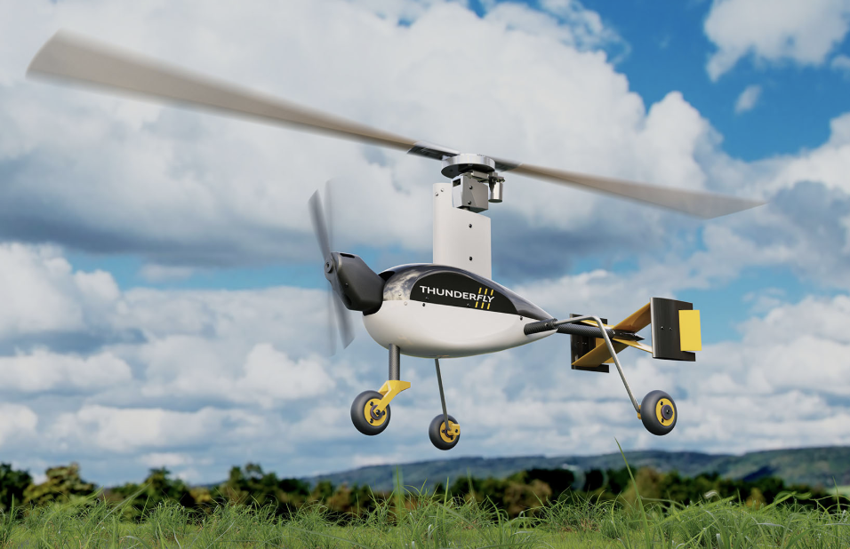

Figure 1.3. Thunderfly TF-G1 unmanned Autogyro. Source: Adapted from [2]

## **Statement of Requirements**

As presented by the sponsor, the autogyro must fulfil the following minimum requirements:

* Manual flight capability using a standard Remote Control (RC) transmitter
* Live video streaming capability
* Descend safely in case of a power or motor failure

The following were described as the reach goals by the sponsor:

* Integration of a flight controller that allows autonomous flight integration
* Integration of an image recognition model to detect sharks
* Camera mount capable of pan and tilt movements to improve field of view (FOV)

For the purpose of this project, the sponsor suggested the use of an off-the-shelf hobbyist autogyro kit to develop and achieve the above requirements by engineering any necessary modifications. Based on this suggestion, more intricate requirements for each aspect of the project were determined as seen in Table 1.

| **Section** | **Requirements** | **Reach Goals** |
| --- | --- | --- |
| Mechanical | * Redesigned fuselage to accommodate Flight Control components * Fixed Camera mount * Redesigned landing gear mount to enhance durability and ease of assembly | * Increased rotor diameter to enhance payload carrying capacity * Pan/tilt capable camera mount |
| Electronics and software | * Wiring harness integrating battery, power distribution, flight controller, ESC, motors, control surface servos, receiver, telemetry radio, GPS, airspeed sensor, camera PCB, camera * Configured FPV camera with live video feed on the internet * Ground Control System (GCS) Radio Communication between GCS and aircraft to record missions and performance * Firmware-flashed flight controller with parameters altered to allow for autogyro flights | * Autonomous flight control firmware to enable autonomous autogyro flight * Prohibit autogyro from performing dangerous maneuvers in autopilot based on telemetry inputs |

**Table 1:** Project Requirements.

The success of the autogyro technology would be dictated by the ability of the autogyro to perform the required mission, planned in advance on a Ground Control System (GCS). The safe descent ability of the autogyro should also be demonstrated as part of a final deliverable of the project.

## **Project Deliverables**

As described by the sponsor, this project was intended to be the first step in a potential multi-part project. Hence, for future engineering students looking to continue this project the following detailed documentation and deliverables were produced:

* CAD files of the autogyro
* Mechanical design drawings
* Bill of materials
* Quick Start Guide
* Analysis and test data
* Fully documented report

All of the above files can be found on the project’s Github.

# Chapter 2: Description of Final Design Solution

The final design solution centers around a modified Durafly Auto G2 V2 Autogyro, which was upgraded with a suite of additional components including a Pixhawk 6C Mini flight controller, DJI Air Unit O4 video transmission system, and a set of sensors which include an IMU (inertial measurement unit), GPS, and an airspeed sensor. These enhancements enable the implementation of autonomous flight and real-time video transmission and streaming for coastal monitoring missions.

The integration of these components required a complete redesign of the fuselage to house the expanded electronics payload while preserving aerodynamic stability. A new fuselage was designed and manufactured to be 33% wider than the original. This redesign retained the original airfoil profile to minimize aerodynamic disruption and ensured sufficient internal volume for neat cable routing, secure component mounting, and future expansion.

For the flight controller, several options were considered as described in Appendix C. The flight controller is the on-board computer flashed with flight control firmware, allowing for tracking status of the UAV through the streamed sensor readings. The Pixhawk 6C Mini, selected for its dual IMUs and open sourced PX4 flight control firmware compatibility, served as the flight control core, enabling waypoint-based navigation via the Ground Control Station (GCS). The DJI Air Unit O4 provided a compact, low-latency FPV video solution, transmitting high-definition footage over RTMP protocol to remote observers. Those architectures will be further discussed in later sections in this chapter.

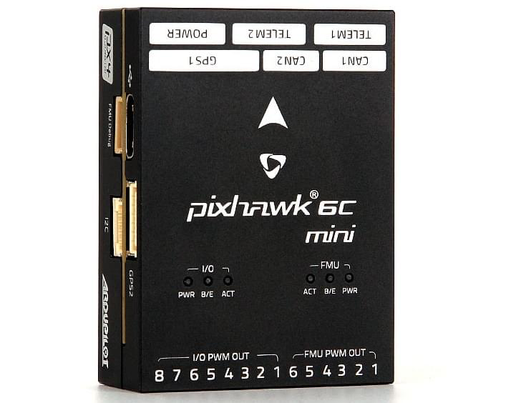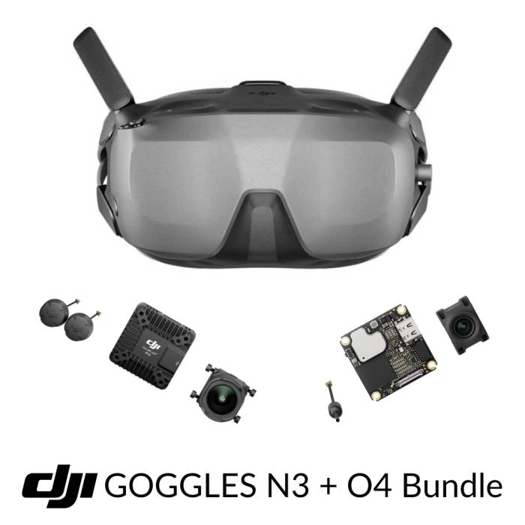

(a) (b)

Figure 2.1: (a): Holybro Pixhawk 6c Mini (b): DJI Goggles N3 + O4 Unit

To ensure stable flight and control, additional mechanical modifications included a custom camera mount and a reinforced rear landing gear mount. These components—critical for stabilizing onboard imaging and ensuring safe landings—are part of a broader mechanical integration discussed in detail later, with annotated illustrations provided in Figures 3.7 to 3.11. Together, these modifications allow the autogyro to perform fully autonomous missions along the Scripps Pier while streaming live video and maintaining the unique safety advantage of autorotative descent in case of power failure.

## **Mechanical Architecture**

The final autogyro design is optimized to ensure modularity, strength, and ease of manufacturability. As stated earlier, the fuselage is 33% wider to ensure that all the electronics necessary for autonomy can be integrated in a seamless manner. The fuselage also features a top latch that spans the entire width of the fuselage and is attached using magnets. This enables greater access to the electronics compartment for easy mounting and troubleshooting. A redesigned rear landing gear mount, designed to enhance durability and ease of assembly, is also incorporated into the design. Figure 2.2 below showcases the final assembled autogyro and is annotated to show the major features discussed above:

Figure 2.2. Fully assembled Autogyro

## **Electronics Architecture**

The electronics system of the autogyro was designed for modularity, reliability, and compatibility with PX4/ArduPilot open sourced flight control firmware stacks. A simplified schematic of the connections is shown in Figure 2.3.

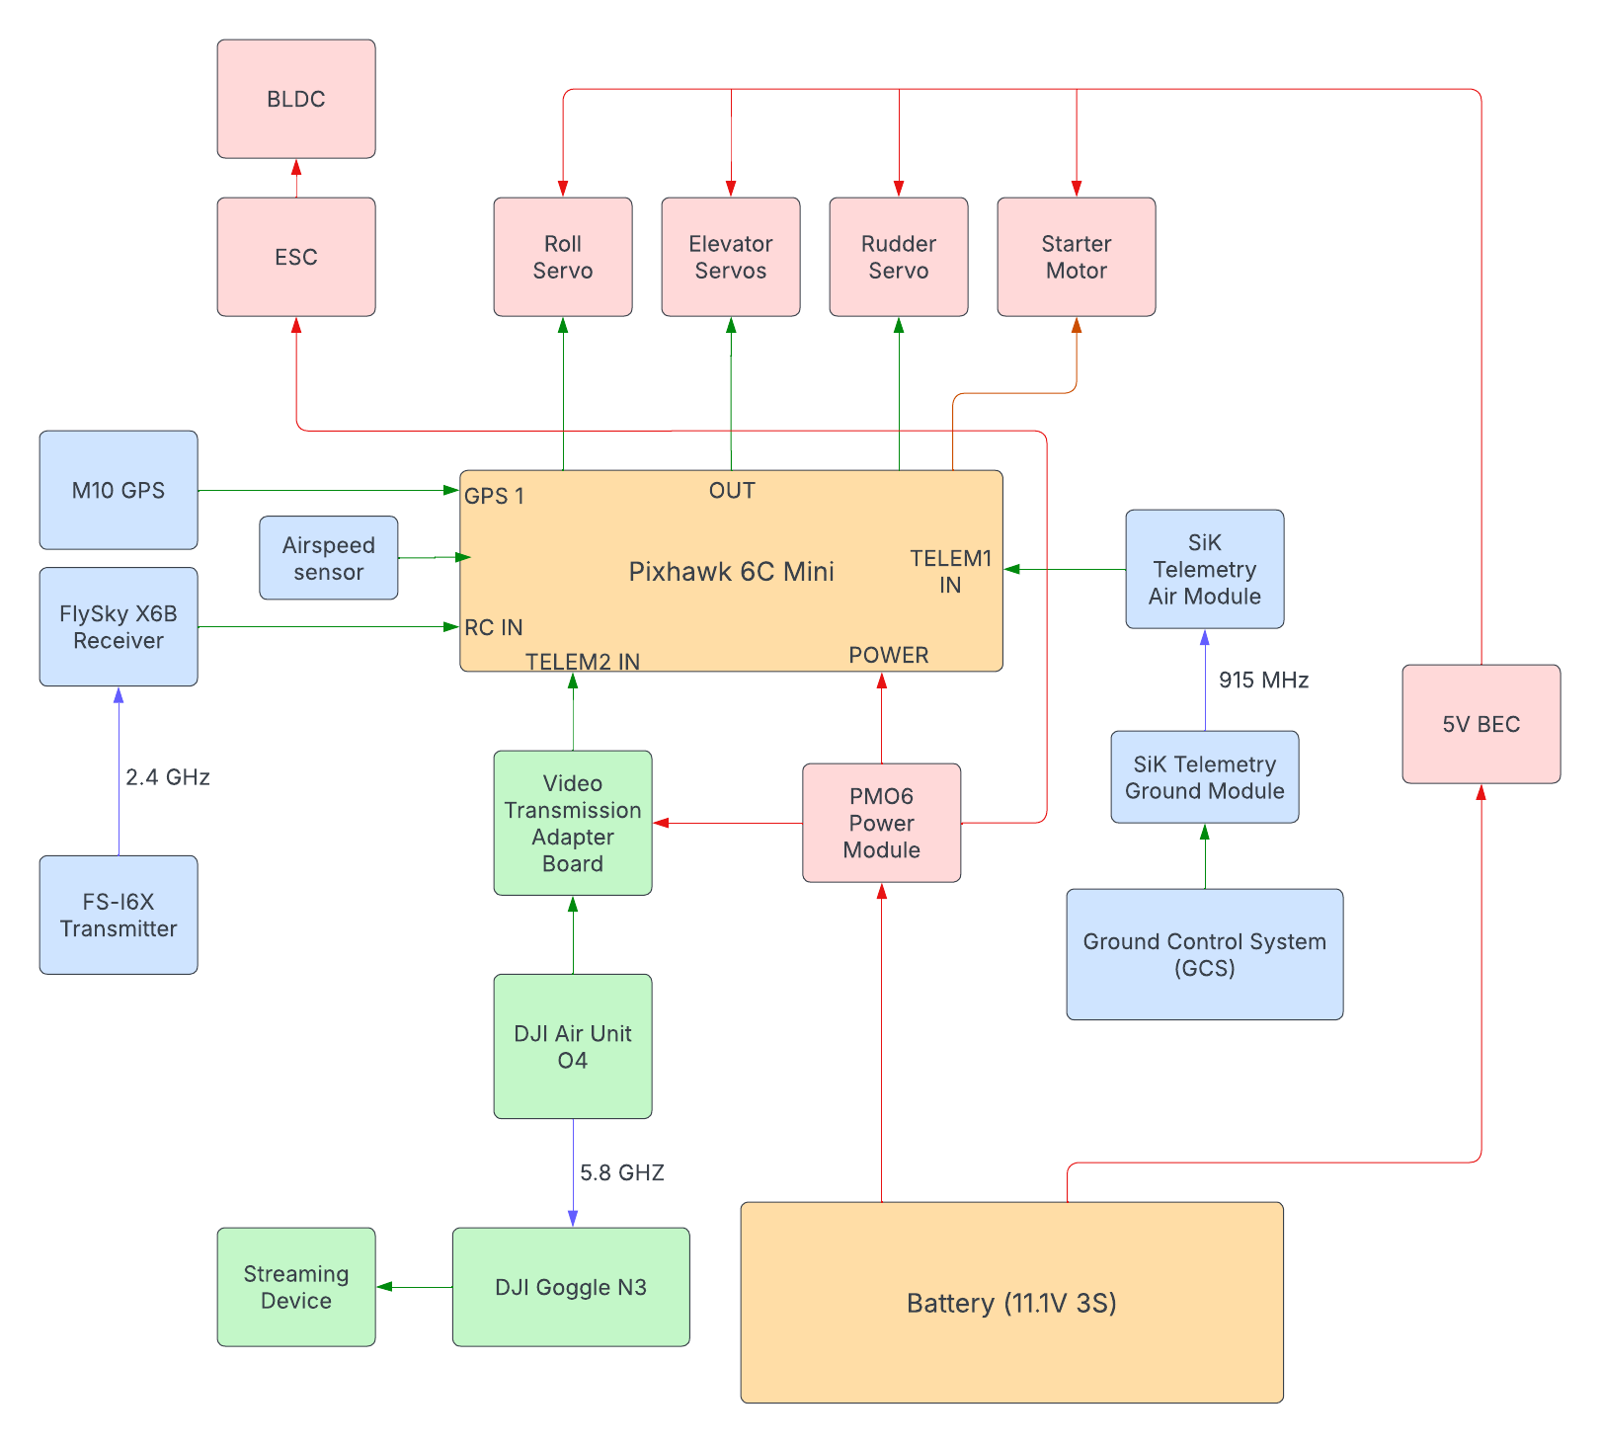

Figure 2.3 Electronics System Architecture

In order to fulfil the requirements of allowing manual flight, autonomy integration, and the camera setup, an intricate wiring harness was developed for the project. The main components of the harness included the following:

1. **11.1V 1300 mAh 3S 45C LiPo Battery:** This was used for development purposes; for extended use, a higher mAh battery is recommended
2. **Holybro PM06 Power Module:** This acts as a Power Distribution Board (PDB) to power the flight controller, ESC and the camera module
3. **Holybro Pixhawk 6C Mini Flight Controller:** This is the onboard flight controller flashed with PX4 flight control firmware. Read Appendix C.
4. **TOYTENSI 20A RC Brushless Motor ESC:** Electronic Speed Controller to run the brushless DC motors, taking PWM inputs from the flight controller
5. **PX4AIRSPEEDV1.1 Airspeed Sensor:** Pitot tube based airspeed sensor streaming to flight controller
6. **Holybro M10 GPS Module:** Provides latitude, longitude and altitude information to flight controller
7. **Holybro SiK Telemetry Radio V3:** Communicates with the Ground Control System (GCS) over 915MHz with 100mW power
8. **FlySky X6B Receiver:** This receiver is used in the manual flight mode when the pilot wants to fly using the FS I6X transmitter
9. **DJI O4 Air Unit:** This module is the on-board camera unit that allows 1080p/4K streaming to the GCS via 5.8GHz radio communication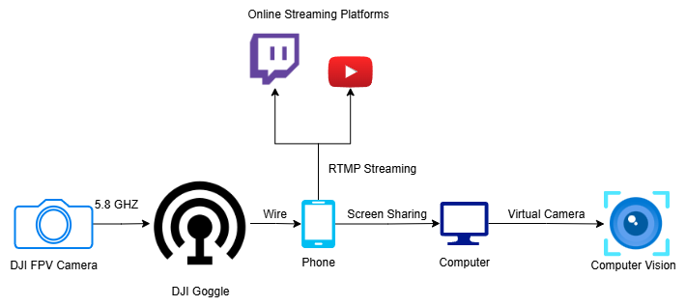

Figure 2.4 Camera Streaming System Architecture

The camera and video streaming system uses the DJI Air Unit O4, which integrates a 4K FPV camera with a built-in encoder and transmitter. As illustrated in Figure 2.4, the video feed is encoded onboard and streamed via RTMP to cloud platforms like Twitch or YouTube, where it can be viewed in real time on mobile and desktop devices. Optionally, the stream can be fed into a computer vision pipeline for object detection (e.g., identifying sharks). This architecture minimizes latency, supports wide accessibility, and is well-suited for real-time environmental monitoring over coastal regions.

# Chapter 3: Design of Key Components

To achieve the objectives of the project, the team designed several key components including the fuselage, rear landing gear mount, and two types of camera mounts. The design decisions behind each of the components and their description will be discussed below.

## **Fuselage**

For the fuselage, the main mechanical design goal was enlarging the original fuselage of the off-the-shelf autogyro (Durafly Auto-G2 V2) to ensure adequate internal space for all required electronic components. This included the Pixhawk flight controller, 1300 mAh LiPo battery, Electronic Speed Control (ESC), receiver, power distribution board, and all the necessary cables. Furthermore, the new fuselage would need to have the exact same internal mounting locations of the rotor tower, servo motors, tail, and starter motor. This is because changing the relative positions of these moving components, shown in Figure 3.1, with respect to each other could potentially alter the dynamics of the system and make it less stable.

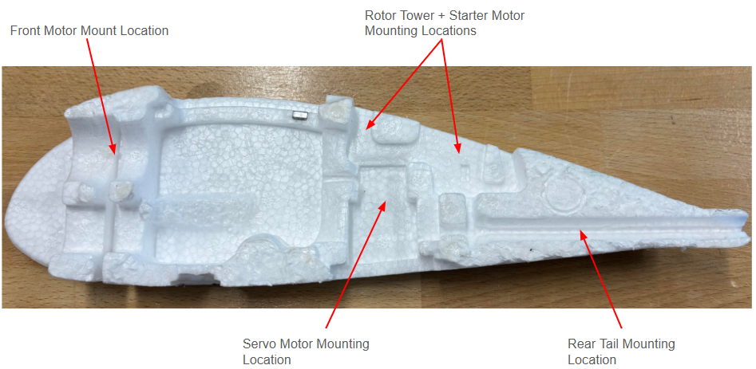

Figure 3.1 Original Mounting Geometry and Relative Component Locations

The original fuselage made of Expanded Polystyrene (EPO) foam had a mass of only 36 grams. Therefore, any enlarged redesign of the fuselage would have to meet the mass constraint. In terms of size, the original fuselage was 75 mm wide. The desired layout of the electronic components was measured, and it was estimated that the new fuselage had to be 100 mm wide to accommodate all components.

The first design considered, shown in figure 3.2, was a truss structure frame similar to a car chassis. This structure, 3D printed from Aero PLA, would then be wrapped with an external skin made of vinyl or some other heat shrink material to create an enclosed fuselage.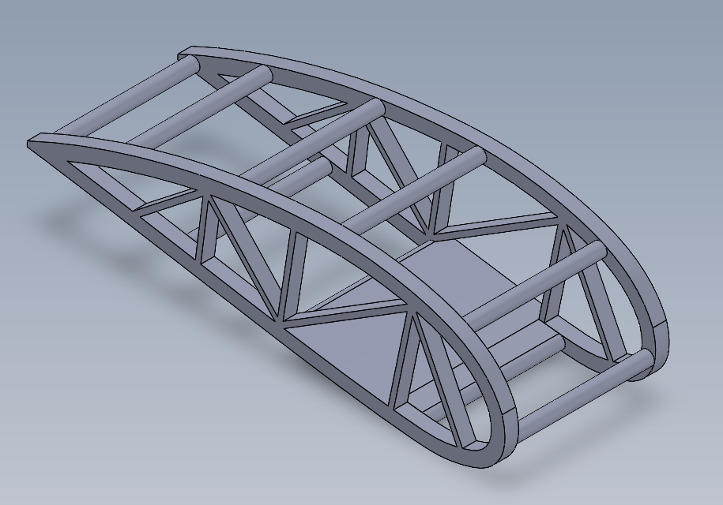

Figure 3.2 Fuselage Design Option 1

This design was beneficial because the truss structure would ensure good mechanical rigidity. However, the main drawback of this design was the mass. Even after optimizing the CAD model for the amount of material used, it was found to be 142 grams. This was significantly more than the original 36 grams goal and thus the team decided not to proceed with this design option.

To minimize the weight of the redesigned fuselage, the best material choice was foam. Extruded Polystyrene (XPS) foam was readily available to the team and with a density of 0.03 g/cm3, it was a good material choice for the second design option. The second design option, shown in Figure 3.3, was a hybrid. It consisted of two core foam sections of the original fuselage joined with epoxy resin to external XPS foam airfoil panels designed to match the original autogyro’s airfoil shape.



Figure 3.3 Fuselage Design Option 2

This would allow the electronics compartment to expand by 25 mm. Furthermore, since the internal portion was from the original fuselage, the mounting geometry for the rotor tower, servo motors, tail section, and start motor would be preserved.

This design was manufactured and test flown. Even though it met the weight requirement, it was found that the XPS panel had very weak impact resistance and failed very easily in a brittle manner. This resulted in the entire fuselage breaking at the electronics compartment upon landing. This is shown in Figure 3.4. Therefore, a stronger external panel would be required for the autogyro which would not break under moderate to harsh landings.

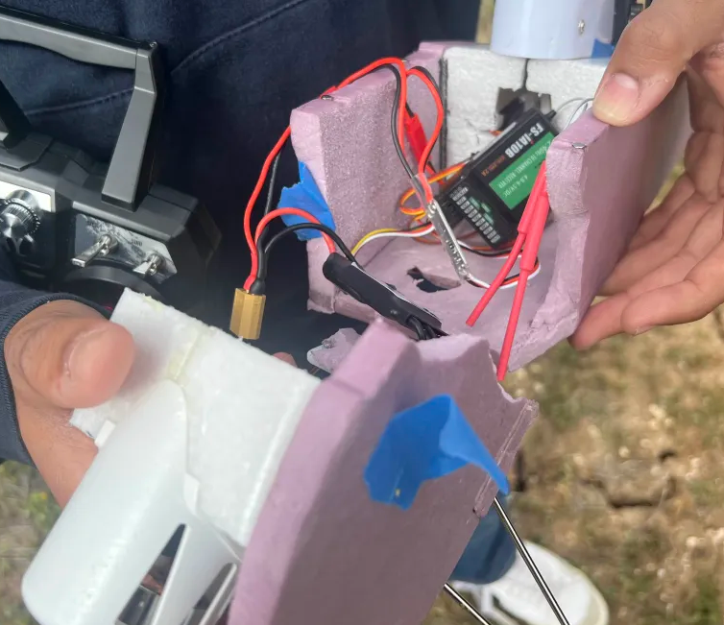

Figure 3.4 XPS Panel Brittle Failure

In order to achieve this, design option 3 was created. For this design, the concept of external panels with the foam core from the original fuselage was preserved. However, the XPS foam was replaced with Expanded Polypropylene (EPP) foam. This foam is significantly more flexible and absorbs impact much better than the XPS foam. Three Carbon Fiber (CF) rods of 3mm diameter were epoxied into grooves made on the surface of the foam to provide additional rigidity and strength. Thus a composite external panel was created. The CAD model for this design is shown in Figure 3.5 and the manufactured panels assembled on the autogyro are shown in Figure 3.6.

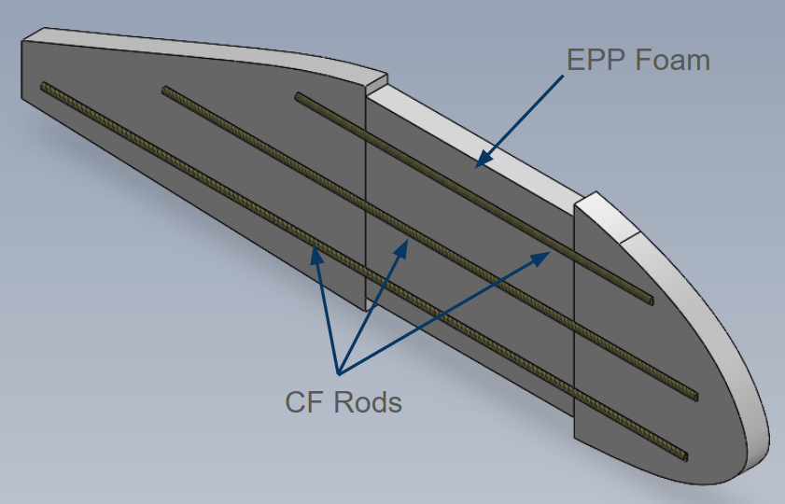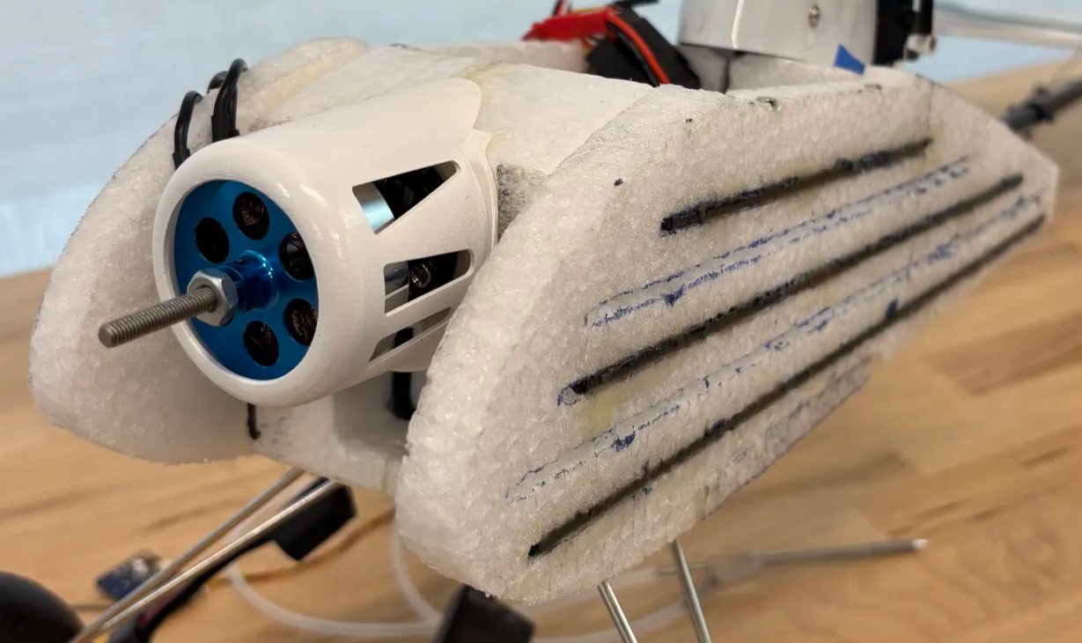

Figure 3.5 Composite panel CAD model Figure 3.6 Composite panels on autogyro

After further testing, it was found that design option 3 held up very well in moderate to harsh landings. Therefore, the team decided to proceed with design option 3. Performance of the composite panel is further discussed in Chapter 4: Prototype Performance. Table 2 summarizes the pros and cons of each fuselage design.

|  | Option 1 (3D Printed Truss) | Option 2 (Original Core w/ External XPS Panel) | Option 3 (Original Core w/ External Composite Panel) |
| --- | --- | --- | --- |
| Advantages | - Good mechanical rigidity  - 3D printing directly would make manufacturing easy | - Original mounting geometry preserved  - Met the weight requirement | - Good mechanical rigidity from CF rods  - EPP foam and CF rods both have high impact resistance  - Original Mounting geometry preserved |
| Disadvantages | - 100 grams heavier than required | - Low impact resistance | - 10 grams heavier than required |

Table 2: Fuselage Design Options Pros and Cons

## **Fuselage Manufacturing Procedure**

As discussed above, the final design of the fuselage consists of the original fuselage mated with the composite foam panels. This design option was chosen as it not only enlarged the internal volume by 33% but also preserved the complex geometry of the grooves where components such as the servo motors, rotor tower and tail shaft were mounted. A key feature of this procedure is that it is streamlined for cost and time efficiency. The step-by-step procedure is described below:

1. The first step in the fuselage manufacturing process to cut sections from the original fuselage that will be mated with the external foam panels. The original fuselage consists of two identical halves, glued along the centerline. Two sections from each half of the original fuselage will be used— the rear section (section 1) and the font propeller housing (section 2). Using a bandsaw, cut each half of the fuselage along the red lines showcased in figure 3.7 below.

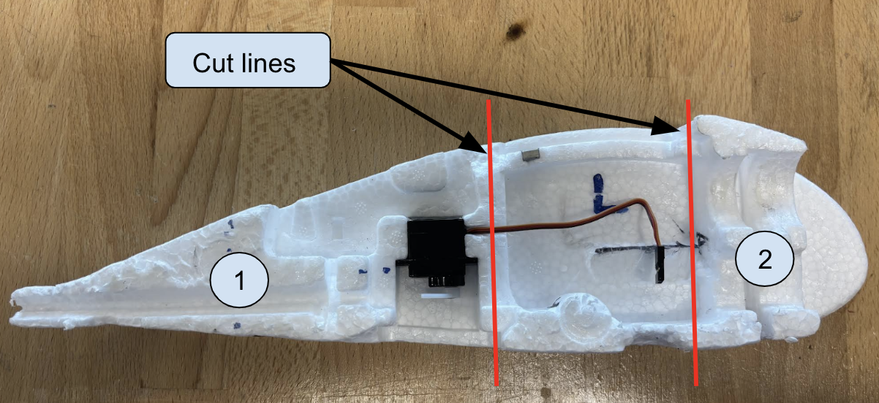

Figure 3.7 Fuselage cut lines

1. Once the fuselage sections have been cut, the next step in the manufacturing process is to use the foam cutter present in the Aerospace Fabrication Laboratory (AFL) to cut the external panels, top latch, and bottom latch using EPP foam. Since the fuselage assembly consists of mirrored left and right sides, two fuselage panels would have to be cut. The required files necessary to manufacture these parts using the foam cutter are included in the Github repository. Then, pour epoxy into the grooves on the fuselage panel and place 4 magnets, each measuring 4 mm in diameter, into the grooves to enable the magnets to be bonded with the fuselage.
2. The next step is to reinforce the fuselage panels with 3 mm diameter carbon fiber rods. Draw 3 parallel lines, each spaced 25 mm apart, along one side of the fuselage panel using a marker. The lines measure 290 mm, 200 mm and 135 mm respectively. Cut the stock carbon fiber rods into these lengths. Then, using a hand-held foam cutter, cut grooves that measure 4 mm deep into the foam along the lines. Pour epoxy into the grooves and place carbon fiber rods into the groove of the corresponding size. Repeat the same process for the other fuselage panel.
3. For the bottom latch, place the front landing gear mounting bracket on one end and trace the groves with a marker. Then, using a hand-held foam cutter, cut grooves that measure 2 mm in depth into the foam along the lines. Pour epoxy into the grooves and place the front landing gear mount over it to ensure proper adhesion. Then, on the other side of the bottom latch, draw 3 parallel lines, each measuring 90 mm and spaced 30 mm using a marker. Cut the stock carbon fiber rods into these lengths. Then, using a hand-held foam cutter, cut grooves that measure 4 mm deep into the foam along the lines. Pour epoxy into the grooves and place carbon fiber rods into the groove of the corresponding size.
4. For the top latch, mark 4 points along the edges where the magnets will be placed. Then, using a hand-held foam cutter, cut grooves that measure 2 mm deep into the top latch at the points marked previously. Pour epoxy into the grooves and place 4 magnets (each measuring 4 mm in diameter) in the grooves.
5. The final step in the fuselage manufacturing process involves assembling all the individual components. First, assemble the rotor tower assembly, servo motors, and the tail shaft to both halves of section 1 of the original fuselage using epoxy. Then, mate this assembly and section 2 (cut from the original fuselage) to one of the composite fuselage panels using epoxy. Once the epoxy has cured, mate the remaining composite fuselage panel to the other side of the assembly using epoxy. Lastly, add epoxy to the bottom latch and mate it to the fuselage.

## **Rear Landing Gear Mount**

Based on early testing it was found that the original rear landing gear mount was a weak point for the autogyro. On multiple occasions this plastic part failed and snapped off during landing. This was most likely because the autogyro was landing with an increased payload (270 grams of simulated electronics payload during risk reduction tests) for which it was not designed. Furthermore, this mount was glued into the hollow back tail of the autogyro. This meant that replacing it after breakage was practically impossible, even if a replacement part was in hand. Thus, the team designed a new rear landing gear mount which could survive these harsher landings while at the same time being easily replaceable. The 2 design options considered are shown in Figure 3.7 and Figure 3.8.

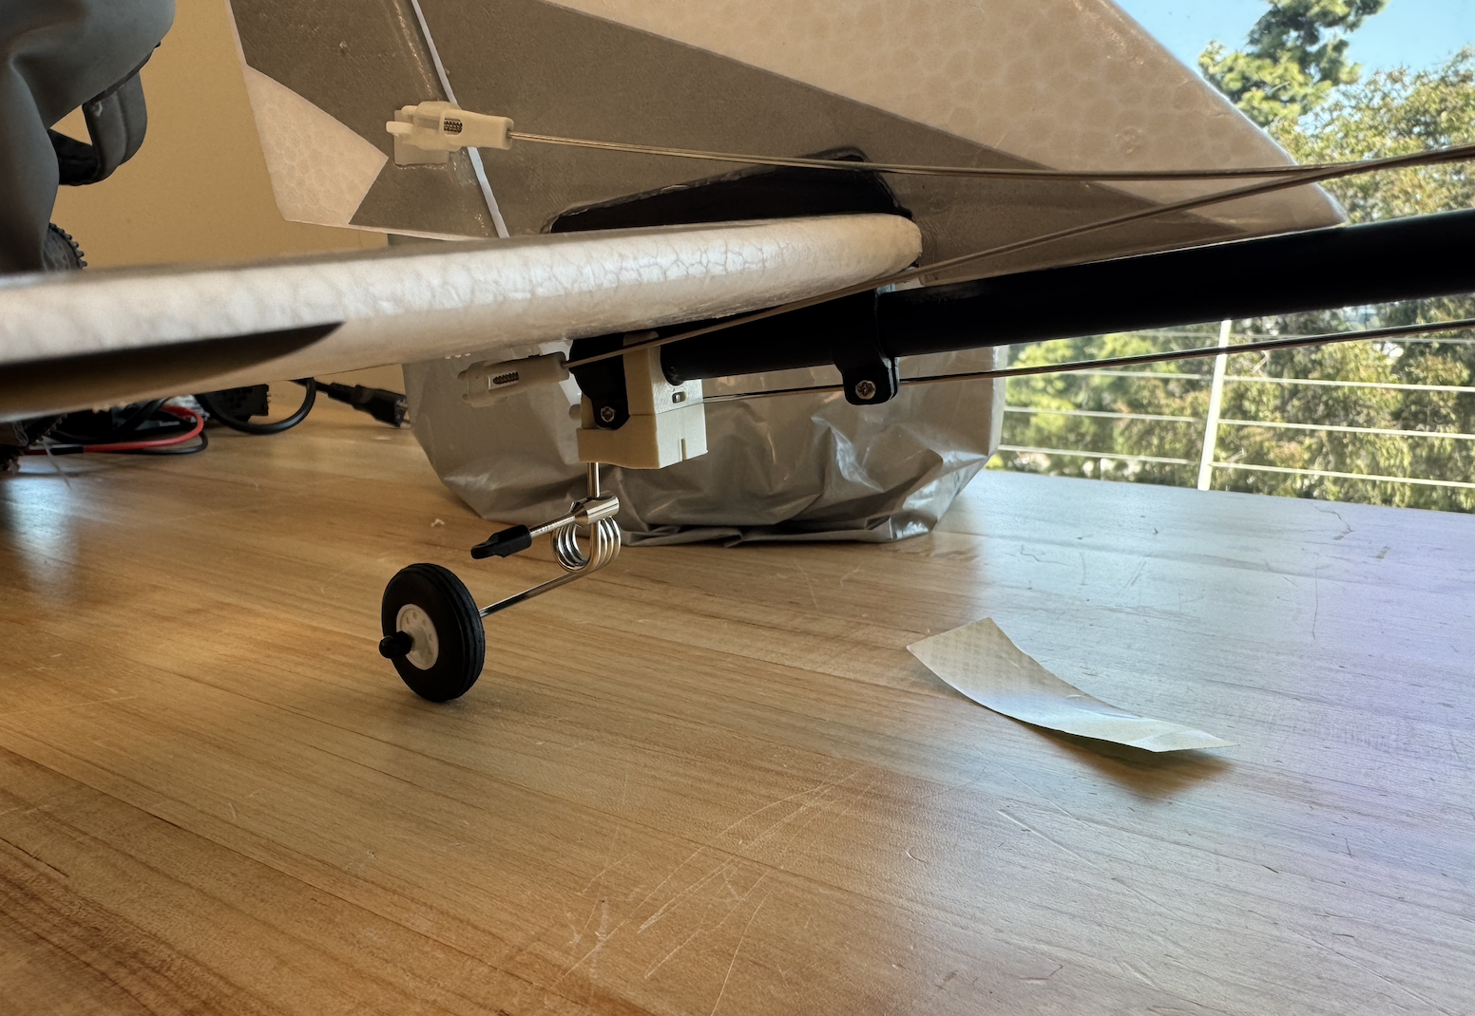

Fig 3.8 C-clamp mount

The first design option, shown in figure 3.7, utilises a c-clamp that mounts to the central shaft of the fuselage using an interference fit. The landing gear mount consists of a two part assembly—the c-clamp that mounts to the fuselage and an interconnect that enables the landing gear to swivel. This part can be 3D printed without the need for support material and is durable and easy to assemble; the clamp is able to be mounted without the need of external fasteners. This design also has the added benefit of acting like a ‘crash structure’ whereby the c-clamp will snap off the fuselage in the event of a hard landing and absorb most of the impact energy, preventing some other part from breaking.

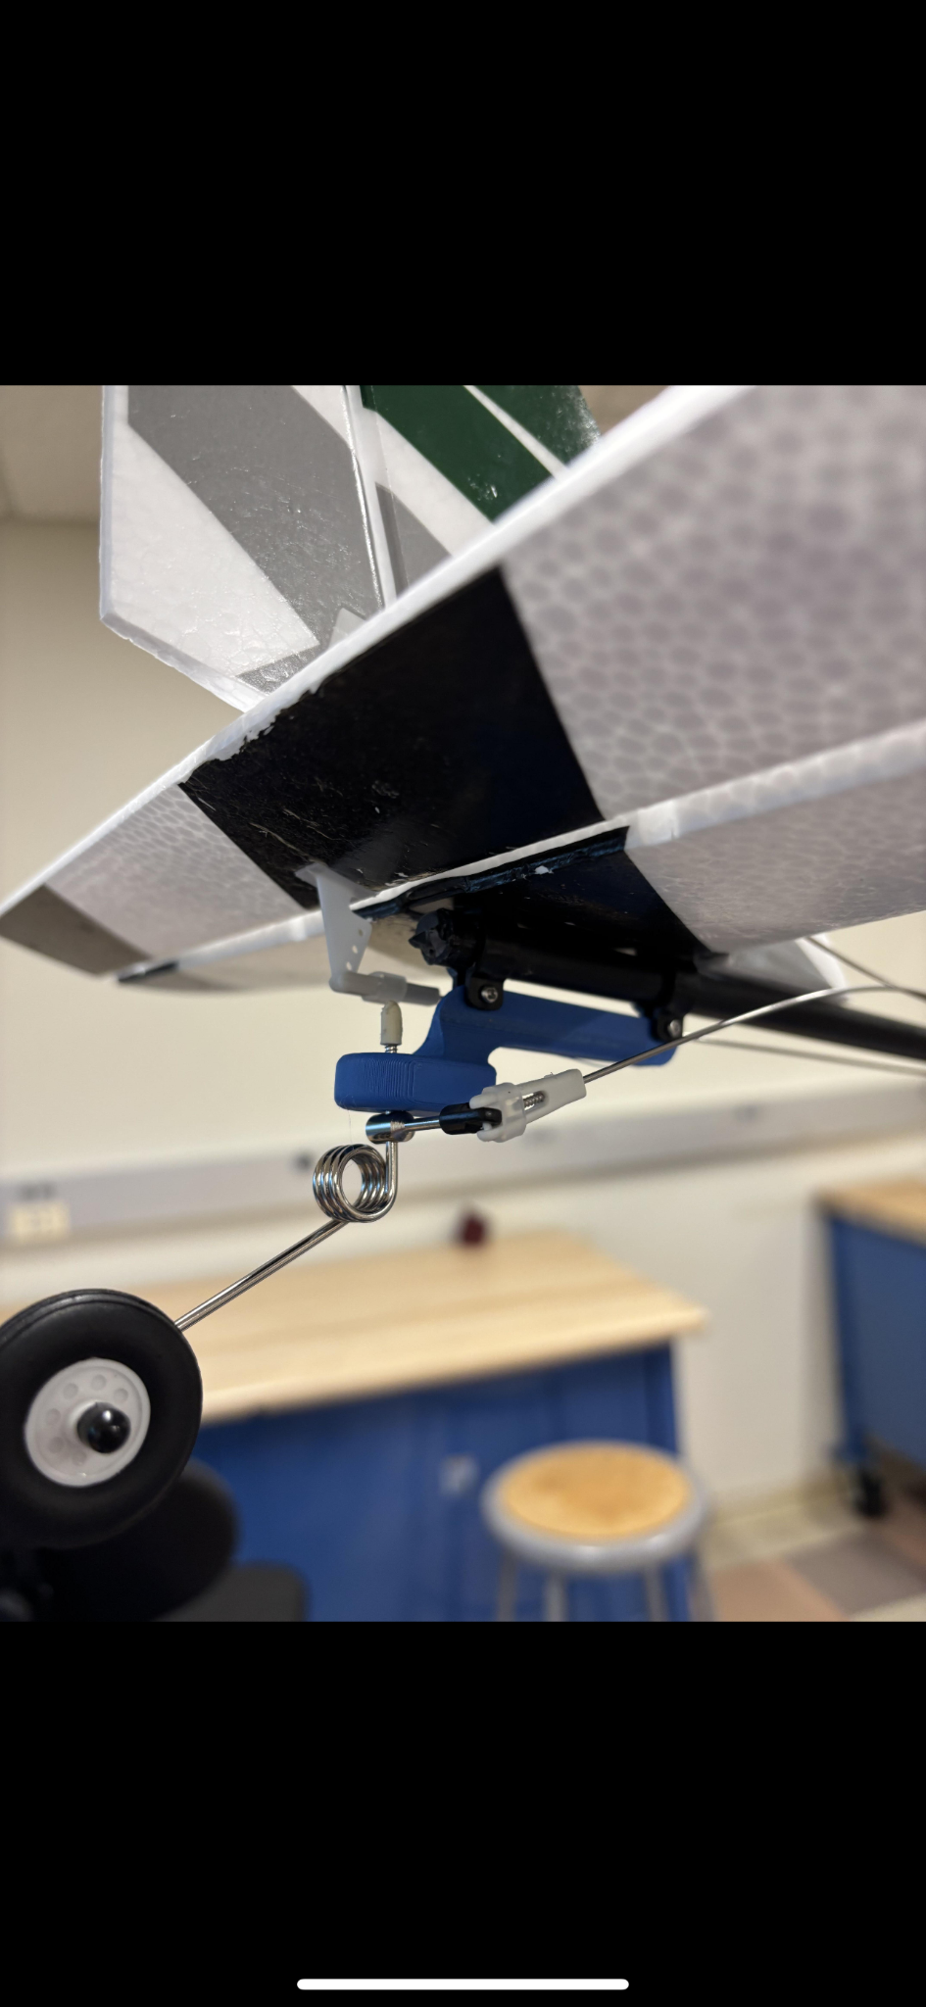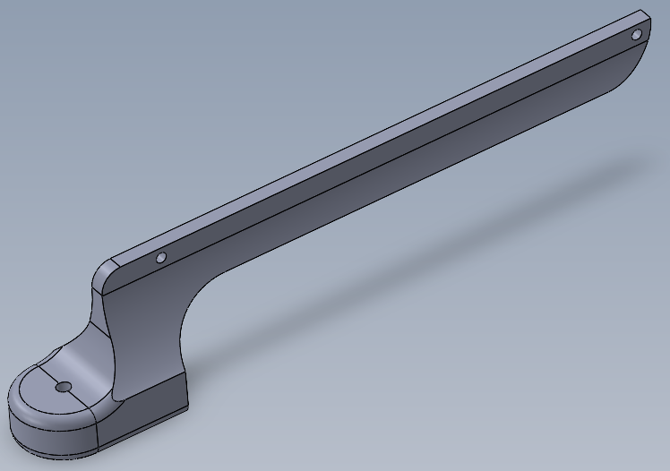

Figure 3.9 Rear landing gear mount option 2 CAD Figure 3.10 Option 2 mount assembled

The second design option, shown in Figure 3.8 and Figure 3.9, utilized the pre-existing screws and nuts used to mount the rear control surfaces assembly to mount onto the autogyro. The advantage of this design compared to the c-clamp option is that it is more permanent and secure due to the use of fasteners. However, because of the use of fasteners, the assembly of this mount would require more time compared to the c-clamp design. FEA simulations were conducted in SolidWorks to ensure that the landing gear could withstand an estimated maximum landing force of 17 N. A factor of safety of 2 was ensured at the critical locations. The simulations were validated through lab testing of the 3D printed part using a spring force scale up to 20N. The part survived without any noticeable deformation or breaking under these tests.

Ultimately, the team decided to proceed with the first design option which was the c-clamp mount. This was because it was easier and faster to assemble on the autogyro as mentioned previously. During field testing, quick repairs are required and faster and ease of assembly is desired. Table 3 summarizes the pros and cons of each design.

|  | Advantages | Disadvantages |
| --- | --- | --- |
| C-Clamp Design | - Quick and easy assembly  - Acts as a crash structure | - Interference fit not as permanent as using fasteners |
| Mount w/ Fasteners Design | - More secure compared to interference fit | - Longer assembly time |

Table 3: Rear Landing Gear Mount Design Options Pros and Cons

## **Camera Mount**

The camera system plays a critical role in the autogyro’s surveillance capability. Two types of mounting solutions were considered: a fixed camera mount and a pan-tilt-zoom (PTZ) gimbal mount.

The fixed mount, shown in Figure 3.10, was designed to minimize complexity and weight. It consists of a 3D printed bracket made from lightweight PLA, mounted directly onto the front of the fuselage. The bracket is angled 45 degrees downward to provide a forward and slightly downward view, optimal for aerial observation during level flight. The primary advantages of this design are simplicity, a light weight of 9 grams, and structural rigidity. However, the main drawback is its lack of flexibility—once mounted, the camera’s field of view cannot be adjusted mid-flight.

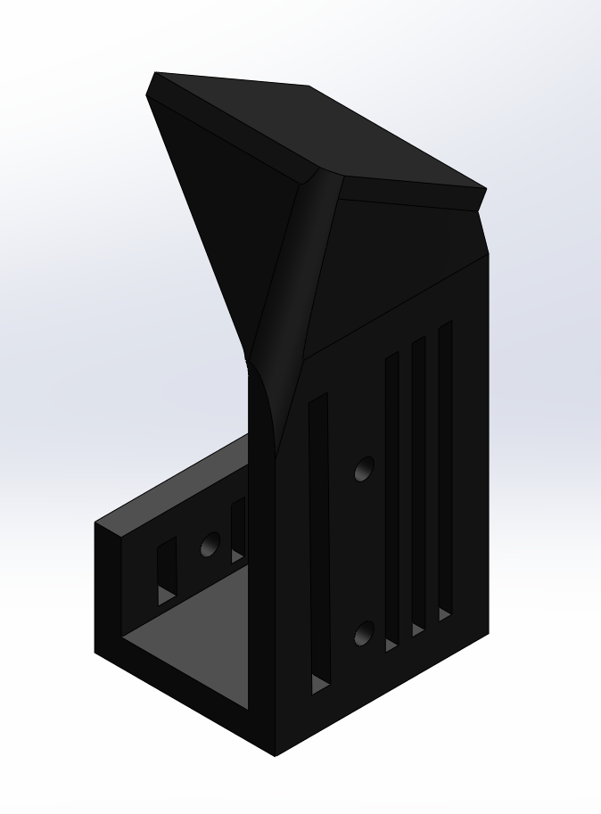

Figure 3.11 Fixed Mount CAD Model

To enable dynamic control of the camera's orientation during flight, a second design option for the camera mount, a two-axis PTZ (pan-tilt-zoom) gimbal mount was designed. The design uses a FS90R continuous rotation servo for pan motion (horizontal rotation), a MG90S micro servo for tilt motion (vertical rotation), and 10:28 reduction gear to improve angular precision and torque transmission.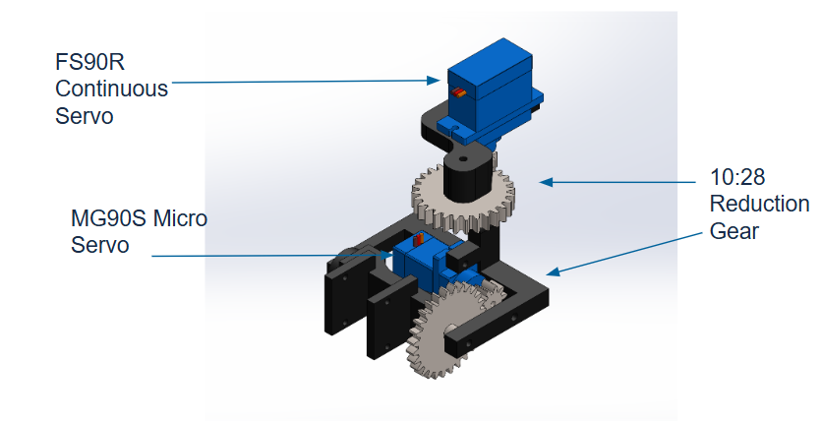

Figure 3.12 Gimbal CAD Model

Figure 3.12 shows the gimbal structure, including both servos and gear reduction mechanism used to control the camera orientation.

The gear reduction setup was chosen to improve fine control over camera orientation while absorbing minor vibrations. The larger gear ratio reduced the load on the MG90S servo and minimized mechanical backlash. The system was mounted on a lightweight 3D-printed frame, optimized for minimal overhangs to simplify manufacturing.

Despite offering a highly controllable viewing angle, the PT gimbal introduced challenges. The mass is increased to 44 grams. There is additional power consumption by motors, and the vibration sensitivity is amplified at the gimbal's moving joints, which was mitigated using foam dampers and rubber isolators.

After weight budget analysis and prototype testing, the team chose the fixed mount as the final design. While the PT gimbal provided better functionality, its weight exceeded acceptable limits and risked destabilizing the aircraft's flight dynamics. The fixed mount offered a lightweight, reliable solution that met mission needs with minimal complexity.

# 

# Chapter 4: Prototype Performance

The final design consists of a redesigned fuselage that is 33% wider than the original fuselage on the off-the-shelf autogyro kit. The new fuselage was designed in such a way that its footprint and airfoil shape exactly matched that of the original fuselage to preserve its aerodynamic characteristics as much as possible.

## **Fluid Simulations:**

To gain a qualitative and quantitative understanding of the airflow around the enlarged fuselage in comparison to the original fuselage, Computational Fluid Dynamics (CFD) simulations were conducted. The theoretical predictions were primarily made using the results from the CFD simulations.

The CFD simulations were conducted using the SolidWorks Flow Simulation wizard. The simulation setup parameters and initial conditions are described below:

* Flight velocity: 10 m/s
* Wind Effects: Neglected
* 0° Angle of Attack
* Rotor and Propeller Effects: Neglected

The images of the flow trajectories from the simulation results is showcased below:

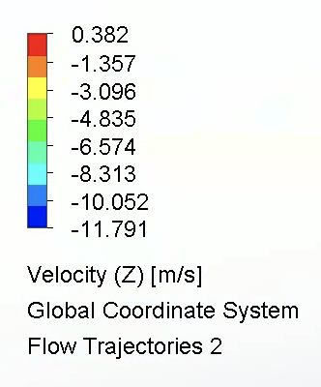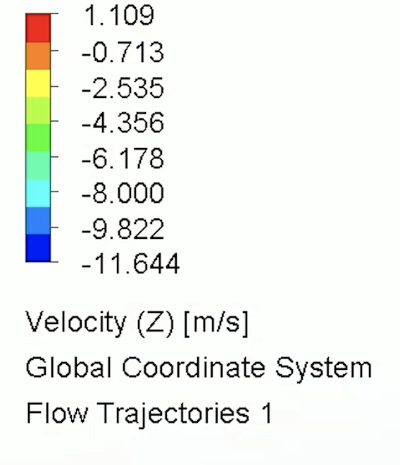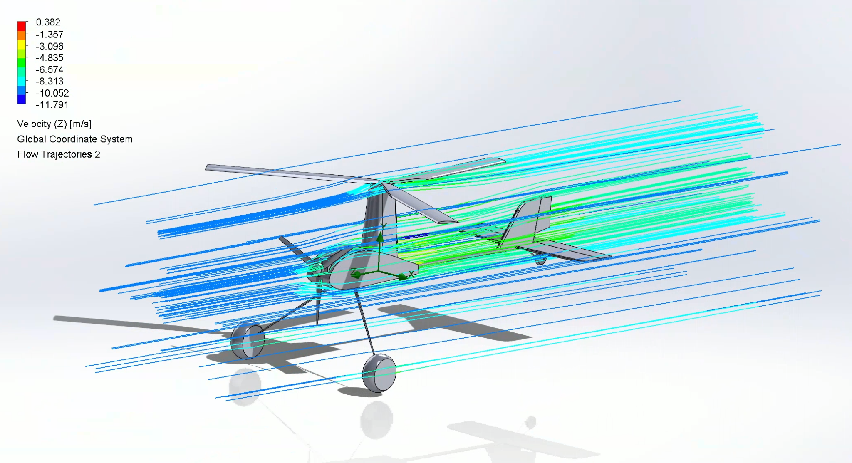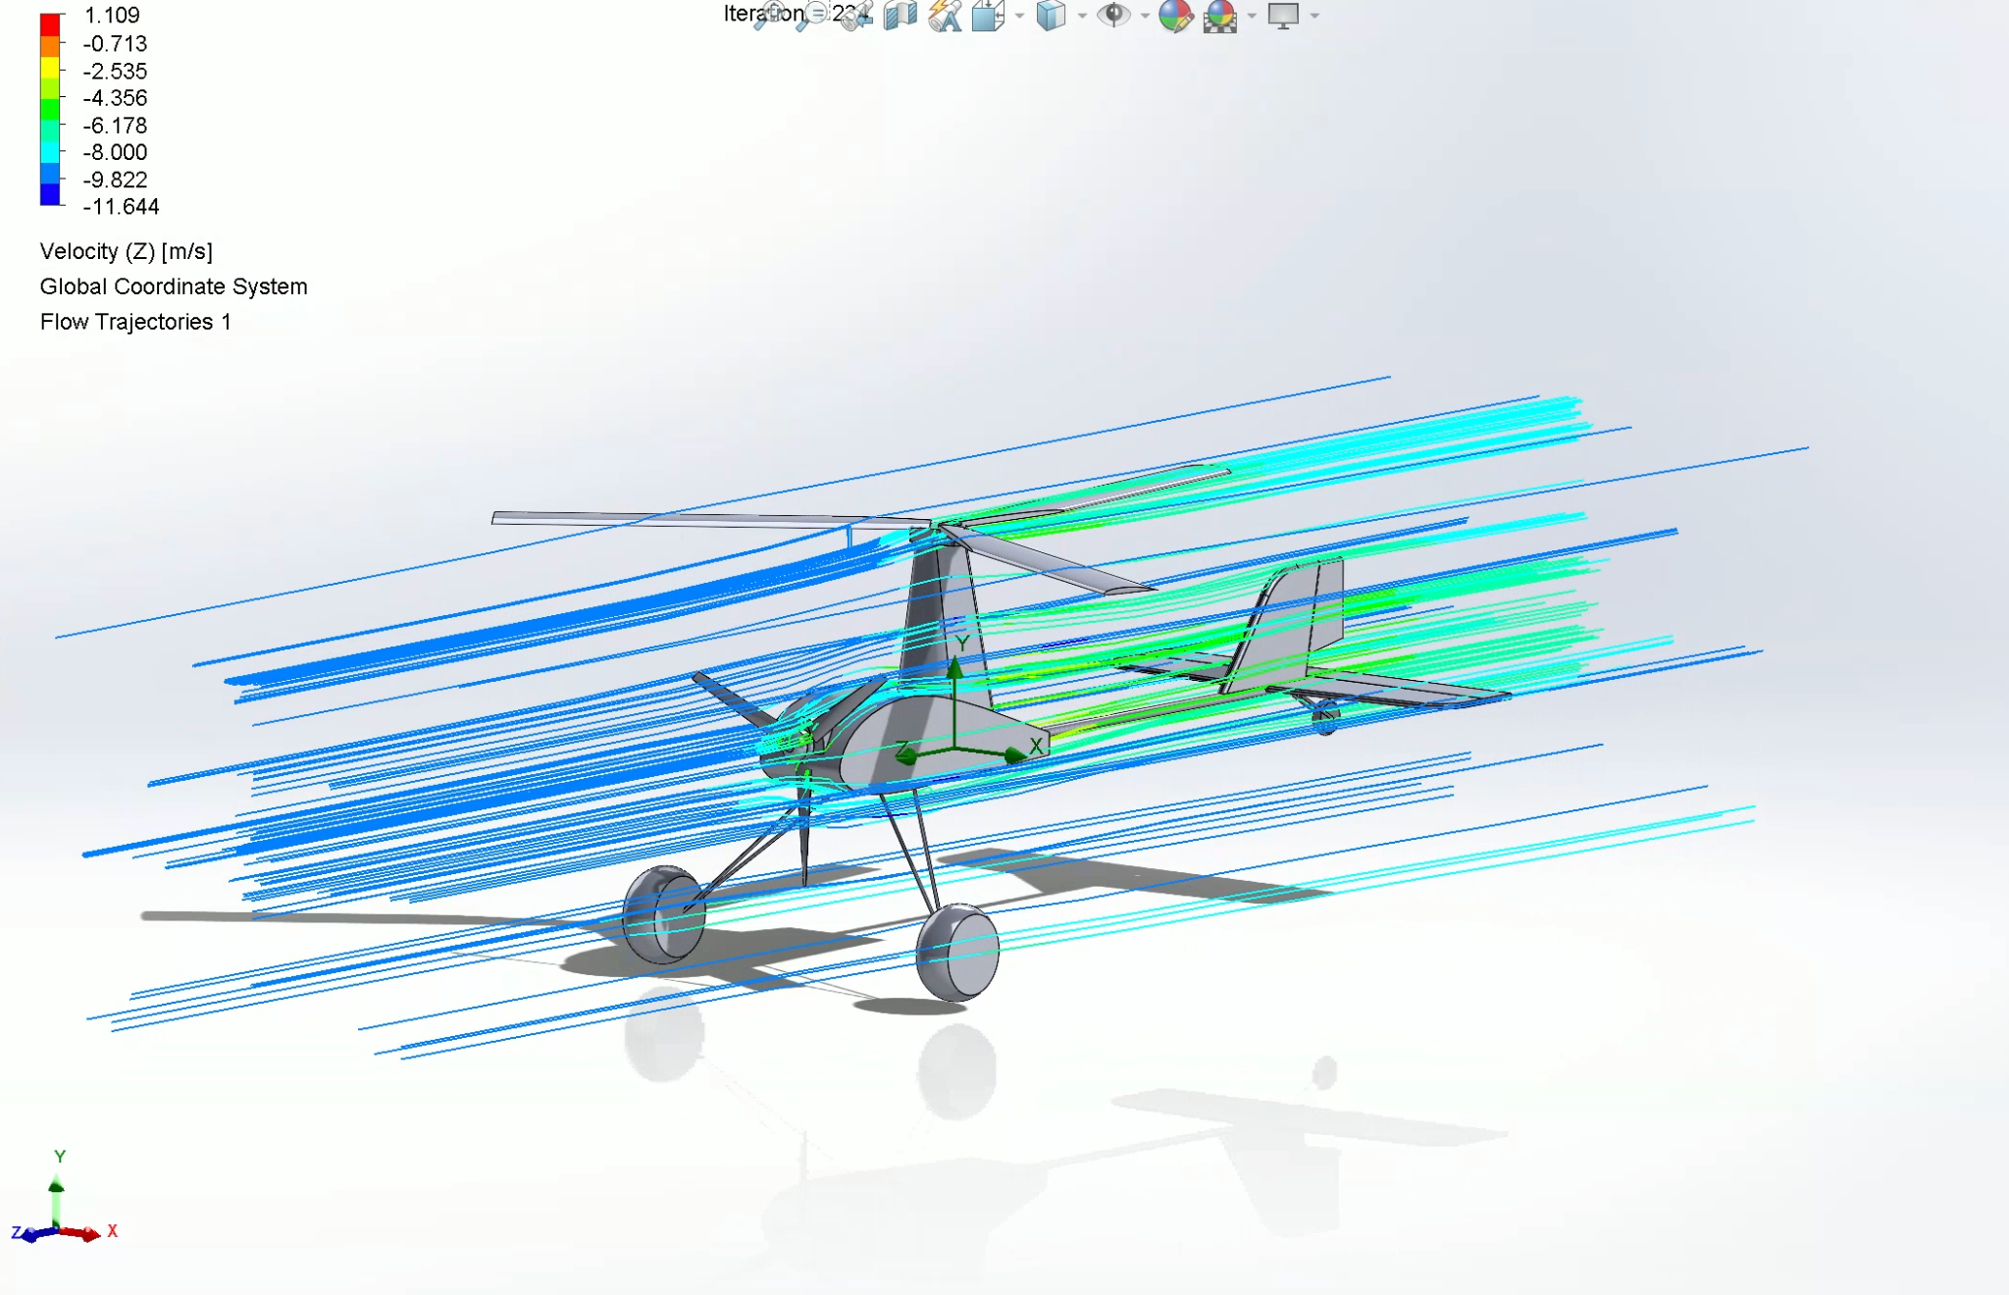

Figure 4.1 CFD simulation: original fuselage Figure 4.2 CFD simulation: enlarged fuselage

As it can be seen from the results of the CFD simulations in Figure 4.1 and Figure 4.2, the airflow around the enlarged fuselage is very similar to the airflow around the original fuselage. Due to their relatively large surface area, the key control surfaces such as the rudder and the elevator have a similar amount of airflow over them enabling them to still be used in conjunction with the enlarged fuselage. While comparing lift and drag between the two fuselage types, the enlarged fuselage had a 9.8% increase in drag and a 19.2% increase in lift. The increased drag is due to the increased cross sectional area resulting from the enlarged width. This also caused an increase in lift due to the increased surface area of the fuselage shaped airfoil. Based on the results of the risk reduction test performed on the original fuselage, the payload capacity of the autogyro is approximately 150g. This is sufficient to carry the required electronics and hardware necessary to enable camera streaming and autonomous flight.

## **Stress Simulations Of Fuselage Panels:**

FEA simulations, shown in Figure 4.3 and Figure 4.4, were conducted to analyze the performance of the XPS foam panel and the composite panel. The motor mount section and rear section were modeled as fixed geometry and an external force of 45N was applied horizontally to the electronics section. A rigid connection was modeled between the CF rod and EPP foam for the composite panel. Linear elastic behavior was assumed.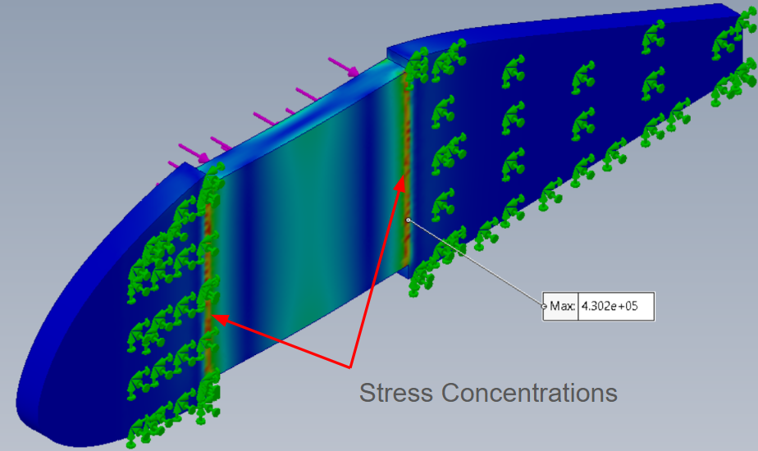

Figure 4.3 XPS Panel FEA Figure 4.4 Composite Panel FEA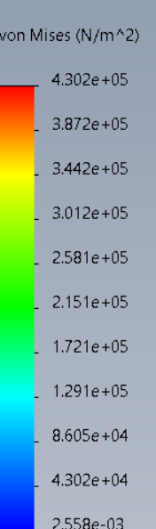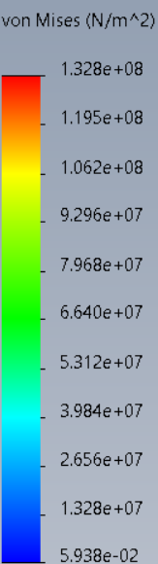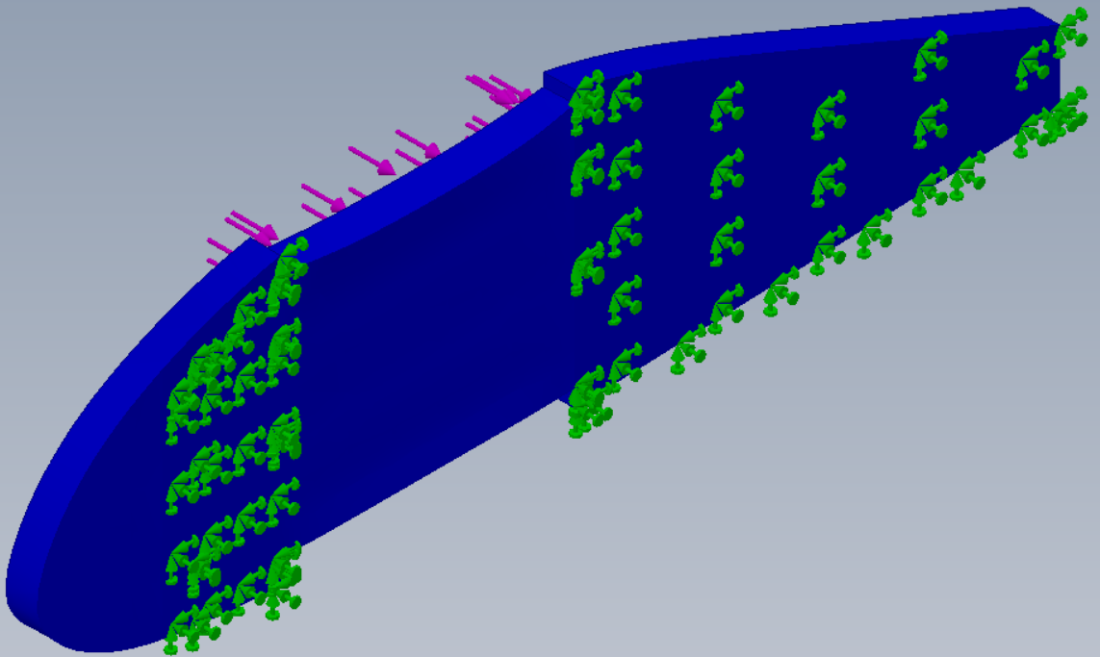

There were two main observations from the simulations. Firstly, the XPS panel showed stress concentrations at the two end points of the electronics section. This was consistent with where failure occurred in real life. However, for the composite panel, these stress concentrations did not exist. Secondly, the maximum stress from the XPS panel simulation was significantly more than the ultimate tensile strength of the foam, and thus failure would occur with that design.

For the composite panel, the EPP foam is significantly more flexible compared to the carbon fiber rods which are more rigid. So, the rods would break first in case of a harsh landing. From the simulations, it was seen that the maximum stress was significantly below the ultimate tensile strength of the carbon fiber rods. In summary, these simulations showed that the composite panel design was much stronger and more durable compared to the XPS panel design.

Lab testing was conducted to validate the FEA results. As shown in figure 4.5 and 4.6, a 230 gram mass was dropped from different heights to compare the impact resistance of the two panels.

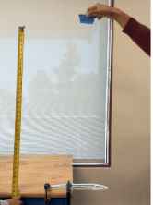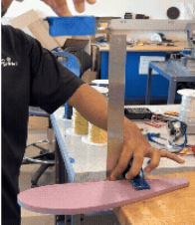

Figure 4.5 XPS Panel Impact Test Figure 4.6 Composite Panel Impact Test

The XPS panel broke after the mass was dropped from 0.3m (1ft), while the composite panel did not break even after the mass was dropped from 0.9m (3ft). This was consistent with the simulations which showed the XPS panel was significantly weaker than the composite panel in terms of absorbing impacts. Thus, the composite panel which was implemented in the final prototype showed great impact resistance during lab testing.

## **Camera Mount Performance**

The fixed camera mount was integrated into the final prototype and tested under various flight conditions. Throughout multiple launches and landings, the mount maintained structural integrity without any signs of loosening or fatigue. The 45° downward tilt proved optimal, offering a stable and useful field of view for forward surveillance during level flight. This is shown in Figure 4.7.

Most importantly, the mount’s low weight—9 grams—helped preserve the aircraft’s designed center of gravity and ensured stable flight dynamics. No significant vibration artifacts were observed in the captured video, validating the mount’s rigidity and its resistance to airborne oscillations.

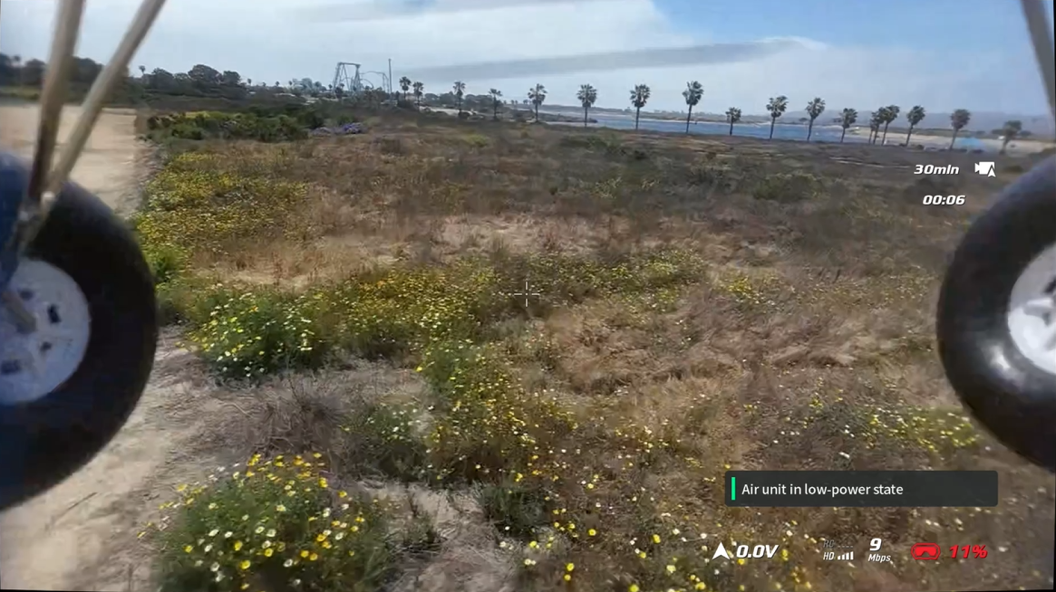Figure 4.7 In-flight Footage Captured from Fixed Camera Mount

Overall, the fixed mount successfully met the design goals of simplicity, stability, and weight efficiency, making it a reliable and effective solution for aerial observation.

## **Video Streaming**

To support remote monitoring and real-time decision-making, the onboard camera was connected to a DJI Air Unit O4, which transmitted the video feed to a ground station and online audience via Twitch. The stream was broadcast in 1080p at 60 frames per second with an average bitrate of 9 Mbps. The DJI OSD overlay provided essential telemetry including signal strength, voltage, and remaining storage.

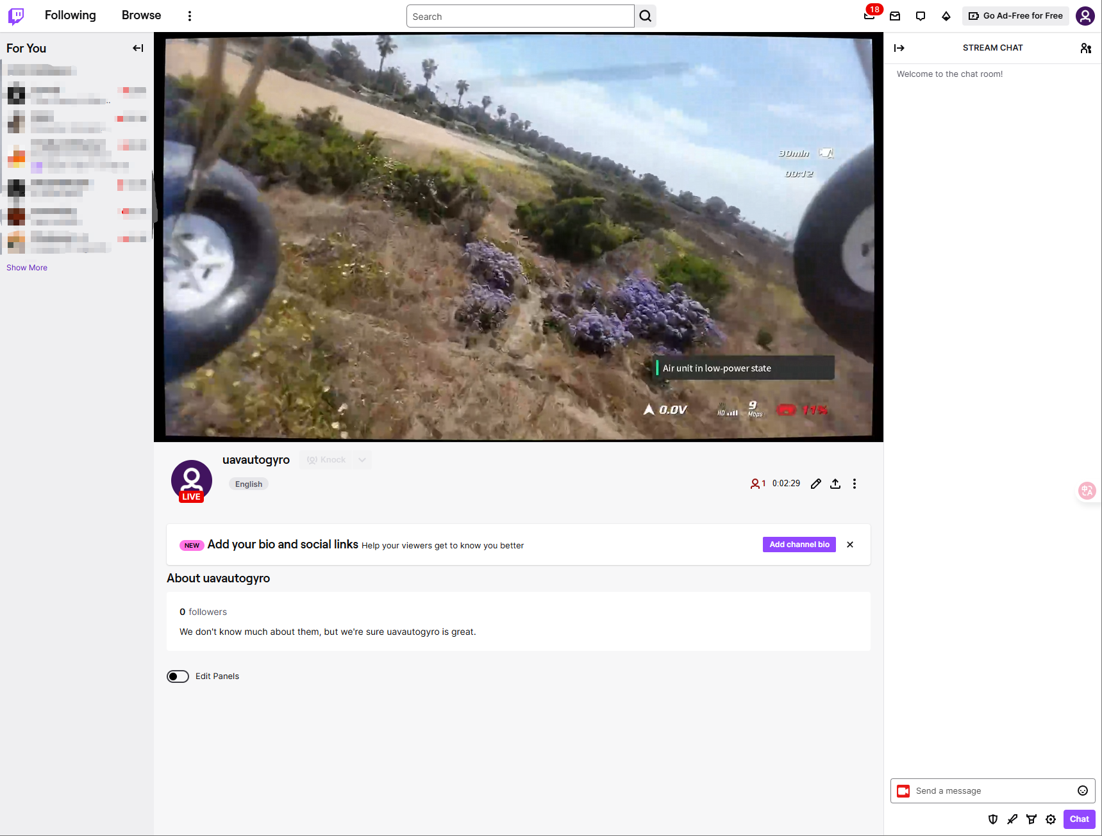

Figure 4.8 Live Stream on Twitch Channel (@uavAutogyro)

This setup enabled remote observation of test flights in real-time and can be extended to multi-view monitoring or mission broadcast in future deployments.

## **Computer Vision Processing**

As a preliminary demonstration of onboard detection capability, the YOLOv8x model was tested on recorded footage from the fixed camera. YOLOv8x is the largest variant in the YOLOv8 family, offering high accuracy but at the cost of increased computational demand.

The model was applied to extract objects from first-person flight video frames. Although the goal was ultimately to detect environmental features such as trees and buildings, the default pretrained model was used, which does not include a dedicated “tree” class. However, the model successfully detected other common classes such as chairs and even airplanes, as shown in Figure 4.9.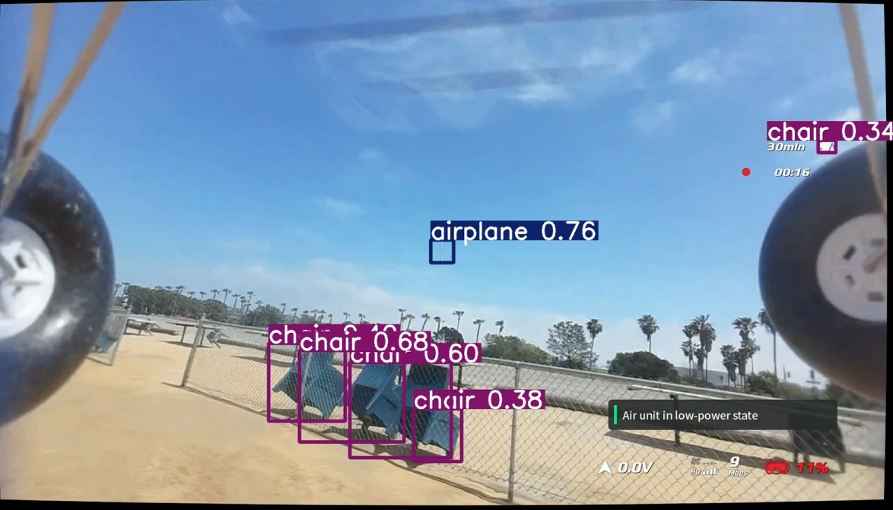

Figure 4.9 Preliminary YOLOv8x Inference Result. (The numbers next to the tags are the confidence of object classification which can be used for object detection purposes)

This result validates the potential for integrating high-performance vision models into the data pipeline. While the preliminary testing used a general-purpose model, YOLOv8x, a high-performance object detection model provided by Ultralytics [3], future work will focus on training a custom object detection model targeting specific objects of interest such as leopard sharks, surfers, and buoys. This will require a dedicated dataset collected from onboard footage and annotated using tools like Roboflow or LabelImg.

The trained model will be optimized for embedded deployment on resource-constrained platforms such as Jetson Nano or Jetson Orin Nano, suitable for real-time inference with GPU acceleration or lightweight alternatives like Raspberry Pi 5 paired with Coral TPU or Intel NCS2 for edge-based model inference.

These platforms will enable onboard autonomous scene understanding, including wildlife tracking (e.g., detecting leopard sharks from aerial view), human activity monitoring (e.g., detecting surfers or swimmers) and environment tagging for safety or research purposes.

## **PX4 Flight Log**

The Pixhawk flight controller generates an in-depth flight log after every flight. This allows for detailed analysis and debugging of mechanical, software and electromechanical aspects of the project.

Latest Flight Log: <https://logs.px4.io/plot_app?log=a41a1dc0-2ae2-454f-bc34-8630157c28f8>

The latest test flight First Person View (FPV) recording for the above flight can be watched at: <https://youtu.be/mpZ1Pg-JWU8>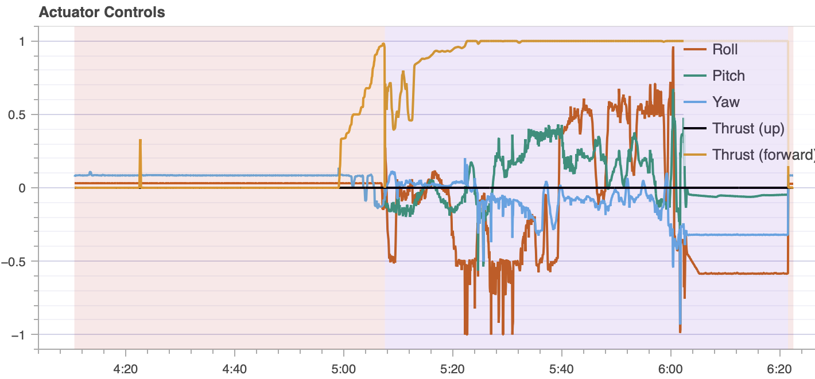

Figure 4.10: Actuator controls from PX4 flight log

As seen in the FPV recording, the autogyro lifts off smoothly, picks up desired altitude and does a circuit. This flight was fully autonomous except as the plane was set to “Hold” mode. This demonstrates that the autogyro is capable of achieving simple maneuvers without in-depth PID tuning with just the use of PX4 Thunderfly Auto-G2 preset. In order to achieve detailed path planning with waypoints, PID autotuning must be done with stable manual flight.

# 

# 

# 

# 

# 

# Chapter 5: Design Recommendations and Conclusions

After having worked extensively on the project over the course of 15 weeks, the team identified certain key areas where improvements could be made. The improvements span across multiple areas of the project and are discussed below:

1. Greater Capacity Battery: Based on the results of the last test flight, the team noted that the current battery (with a capacity of 1800 mAh) was potentially causing current spikes leading to the autonomous mode being triggered when it wasn’t supposed to. To resolve this issue, the team recommends switching to a larger battery (with a capacity of 2500 mAh) which is more optimized for the system requirements for running the Pixhawk along with the live streaming of the camera feed.
2. Fuselage Lengthening: The current fuselage was designed to have sufficient capacity for the payload with the 1800 mAh battery. Therefore, if a 2500 mAh battery is to be used instead, the team recommends lengthening the fuselage. This can be achieved by increasing the horizontal length of the payload bay by 15 mm, leaving all other dimensions and manufacturing process unchanged. This will enable the larger 2500 mAh battery to be integrated into the fuselage, potentially mitigating the issues faced during testing.
3. Increasing Rotor Diameter: To further enhance the payload carrying capacity of the autogyro, the team recommends increasing the diameter of the rotor blades. Since a majority of the lift is generated by the rotor blades, this can greatly improve the payload carrying capacity of the autogyro enabling it to carry greater payload and improve its flight performance.

If the recommendations discussed above are implemented, the team strongly believes that the autogyro will have enhanced performance, increased flight time, and improved handling characteristics.

## **Impact on Society**

As mentioned previously, one of the most significant positive impacts of autogyro technology on society is the improved safety it provides through gradual descent in the event of motor or power failure to the UAV. Whether used for monitoring purposes near the shoreline or for urban food delivery, a rapidly falling drone poses much greater risk of injury to humans below than an autogyro. Furthermore, since autogyros only have 1 main motor, they use less energy compared to drones which use either 4 or 8 motors. Thus, autogyros are more sustainable and good for the environment.

Additionally, the video feed—which can be used to spot leopard sharks and track their movements—is valuable to biologists and marine life enthusiasts interested in observing these creatures in their natural habitat. Leopard sharks pose virtually no threat to humans, and swimming or snorkeling alongside them is a popular activity. Thus, the live video feed from the autogyro surveying the La Jolla shoreline can help guide visitors to optimal viewing locations and enhance public engagement with local marine ecosystems.

One potential concern of an UAV autogyro is the noise created by the top rotor. Based on testing, it was found that this is mostly noticeable during sharp or banked turns. Thus, as long as the autogyro avoids such maneuvers during flight, the noise should not be too much to disturb people below.

## **Professional Responsibility**

As engineers in the modern world, ensuring the project upholds professional responsibility is an important aspect of this course. This project upholds the principles of professional responsibility in the following ways:

* **Legal Obligations:** This project abides by all the required FCC and FAA rules and regulations with regards to flying RC aircraft. All the test flights are conducted in airspace designated for RC flying.
* **Prioritizing Sponsor’s interests:** The project team meets with the sponsor on a weekly basis to ensure that they are kept up to date with the project’s progress and that any of their concerns are immediately addressed.
* **Financial Management:** The team carefully evaluates each product before purchasing it to ensure that it meets the needs of the project.
* **Ethical Conduct:** The team members ensure that they always act with transparency, integrity, and fairness.
* **Engineering Competence:** The team ensures that all design decisions are supported with engineering knowledge and experience.
* **Future Compatibility:** The team will ensure that documentation regarding the flight characteristics of this RC autogyro is created to enable future teams to make progress in an efficient manner.

## **Applicable Standards**

An important part of any professional engineering project is to ensure that it abides by all the necessary professional standards. This ensures safety, efficiency and consistency in the design. The project development abides by the following standards:

**Federal Aviation Administration (FAA) Standards:**

* FAA AC 91-57: This relates to the safe usage of recreational RC airplanes. The project team ensures that it abides by this standard to safely conduct all test flights

**American Association of Aeronautics and Astronautics (AIAA) Standards:**

* AIAA S-102.1-2014: This relates to the use of Failure Reporting, Analysis & Corrective Action System (FRACAS) in the development and testing process. The team will understand the different points of failure observed during testing, evaluate them, and then systematically work on addressing them.
* AIAA G-077-1998(2002): This relates to the use of Computational Fluid Dynamics (CFD) in the development process. The project team will conduct CFD simulations on the autogyro to better understand flow characteristics and then optimize the design to maximise stability and flight performance.

**American Society of Mechanical Engineers Standards:**

* ASME Y14: All technical drawings from the project will be prepared in adherence to ASME Y14 standards. This ensures that future work can be conducted on the project and previous documentation can be easily understood by the new engineers.

**Camera and streaming standards:**

Our system integrates the DJI Air Unit O4 to transmit real-time video over RTMP protocol for local processing and remote monitoring. To ensure product safety, interoperability and global applicability, the following standards are referenced:

**RTMP Protocol**

* Follows standard multimedia protocol for real-time video delivery over IP.

**IEEE 802.11**

* Used for enhanced Wi-Fi connectivity on supporting ground devices, ensuring compatibility and global interoperability.

**FCC Part 15 Compliance:**

* Ensures RF modules operate safely within unlicensed ISM bands without causing harmful interference.

**TÜV/UL/CE Marked Power Supply Standards:**

* Guarantees electrical safety and reliability of power components

**Sustainable Design Consideration (RoHS, WEEE):**

* Limits hazardous materials and supports responsible electronics recycling.

# Acknowledgements

Our team would like to thank the following people for their help and guidance for our project:

MAE 156B Instruction Team: Professor Jerry Tustaniwskyj

Yifei Zheng

Project Sponsor: Professor Robert Heath

MAE Engineering Staff: Paul Arcoleo

Stephen Mercsak

Chris Cassidy

Steven Roberts

Thomas Chalfant

Silent Electric Flyers of San Diego: Steve Manganelli

# References

[1] Rainbow Autogyro website: https://www.icare-rc.com/rainbow.htm

[2] “TF-G1,” Thunderfly.cz, 2019. https://www.thunderfly.cz/tf-g1.html (accessed May 22, 2025).

[3] G. Jocher et al., “Ultralytics YOLOv8,” GitHub, 2023. https://github.com/ultralytics/ultralytics (accessed May 24, 2025).

# 

# Appendix

## Appendix A: Individual Component Analysis - Ease Of Modifications For Potential Autogyro Options (Arham Nawaf)

Brief Project Description:

The main goal of the project is to monitor the wave conditions and sea life along the shoreline near Scripps pier. This will be done using live video footage broadcast from a camera mounted to a gyrocopter. The reason a gyrocopter is being implemented is because unlike drones (which are traditionally used for such applications), the gyrocopter doesn't fall straight down in case the main motors lose power. Instead, due to the automatically gyrating top rotor, it is able to come to a gradual descent. This is ideal not only for the vehicle itself (since it won't have a catastrophic failure due to the loss of power), but also safer for beach goers due to the capability of gradual descent at a lower velocity compared to a drone falling straight downwards from midair.

The course of plan for the team is to purchase an Autogyro kit from the different options available in the market, assemble the vehicle, and modify it to fit the required application. After identifying 5 potential buying options, research was conducted to find out the best one for this project's application.

This analysis specifically focuses on the ease of modifications for each option. The objective is to identify the option which is easiest to modify going forward. Factors such as price, material, specifications before modifications, ease of mounting external components, and potential amount of modifications required were considered.

Functional Requirements:

* The material the Autogyro is originally made of should be easy to work with. This will facilitate tasks such as external mounting of other components via drilling holes in the fuselage and possible weight reduction via removal of material from the main fuselage. (This will be done in a way that does not compromise structural rigidity and flight capabilities.)
* The material the Autogyro is made of should be resistant to moisture since the application involves the vehicle flying near the sea where the air is more humid compared to inland conditions.
* The fuselage of the Autogyro should have space, either externally or internally, to mount a camera, batteries, and control system hardware.
* If the original motor or propeller needs to be swapped out as a modification, the replacement parts should be easily available for that Autogyro on the market.

Description of 5 options:

The main 5 options are:

1. Durafly Auto G2 V2
2. Thunderfly TF-G2
3. Rainbow Autogyro
4. RPG Autogyro V2
5. MIA EZ Gyro 1.o

The advantages and disadvantages of each Autogyro are considered below:

**Durafly Auto G2 V2** : The fuselage/main body of this Autogyro is made of EPO foam. This is a standard material generally used by hobbyists in RC planes. EPO foam is lightweight and impact resistant. The lightweight nature means less energy will be required to fly the gyrocopter or to generate lift. In case of a crash, the impact resistance will ensure less damage since the foam absorbs some of the energy from the impact. Furthermore, EPO foam is quite easy to work with compared to other materials such as carbon fiber or balsa wood, which are two other materials often used to construct RC planes. For example, EPO foam can be easily drilled into, cut, sanded, or glued, thereby enabling easy modifications. Additionally, EPO foam is relatively more water resistant compared to wood for e.g, which tends to absorb water and warp over time. However, if any external fasteners are accidentally overtightened onto EPO foam, this will cause the material to compress and may potentially compromise the structural integrity of the fuselage.

The manufacturer of this Autogyro has indicated that the Autogyro "should not be flown in poor weather, high winds, and fog or mist". This description is a little vague since "high winds" were not quantified by the manufacturer. But depending on the conditions near Scripps pier, additional modifications to the elevator/rudder/ailerons/flaps of this Autogyro may be required to produce more stability.

For this Autogyro, it can be seen from the below picture that there is sufficient space on the fuselage and rotor tower (circled in red) to mount electronics or a camera externally. This is ideal for ease of modifications. This advantageous feature of this Autogyro is unlike one of the options that will be discussed later.

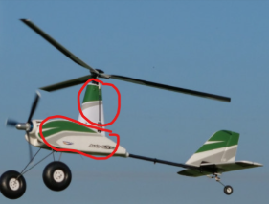

Finally, this Autogyro is sourced from hobbyking, which is a popular hobbyist website for airborne RC vehicles. Thus, there is a large selection of replacement parts to choose from. And since it is located in the US, shipping times are short and beneficial for the team.

**Thunderfly TF G2**: Compared to the Durafly Auto G2 V2, the manufacturer of the Thunderfly TF G2 has clearly mentioned a wind gust resistance of up to 10 m/s. According to wind speed data from [this source](https://www.surf-forecast.com/breaks/Scripps-Pier/wind-stats) of the yearly average wind speeds near Scripps pier (since 2006), the largest wind speeds are 30+ kph = 8.33+ m/s and they only occur ~1.5% of the time throughout the year. The chart is shown below:

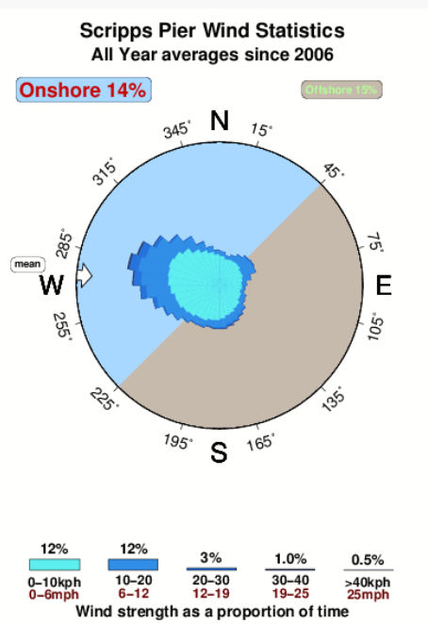

Thus, it can be expected that the Thunderfly TF G2 would comfortably function for this application near Scripps pier. Hence, this Autogyro would require the least amount of modifications to its propellers/elevator/rudder/ailerons/flap to stabilize it. The additional advantage of this Autogyro is the design of its fuselage.

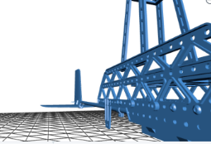

As can be seen in the picture above, this Autogyro already has a lot of holes on its fuselage which can be used for mounting external components. Thus, this option will require the least amount of modifications (for e.g, drilling extra holes).

Finally, this Autogyro is custom designed in the Czech Republic, hence replacement parts are few to come by and will be difficult to source for the team.

**Rainbow Autogyro**: The manufacturer quoted a flight time of approximately 10-20 min which is on the lower end of the spectrum. The fuselage would have to be modified to accommodate a larger battery. As an upgrade, a 4 bladed head assembly is available from the manufacturer which gives the ability for additional payload. However, the manufacturer has highlighted that this 4 bladed configuration is not meant for windy conditions, which is the case near Scripps pier. Besides this, there was an overall lack of documentation and information from the manufacturer for this Autogyro which is not ideal to make an informed decision to purchase it.

**RPG Autogyro V2:** The main body of this Autogyro is of wood construction. As mentioned before, compared to EPO foam, wood is a very poor choice of material for an aircraft for this application since the vehicle will be exposed to some amount of moisture overtime. The wood will over time absorb moisture (from the humid air near the shoreline) and degrade, potentially warping. As modifications, lots of extra methods of waterproofing such as sealing, varnishing, and painting will have to be implemented. These modifications do not aid the goal of the project and are instead going to be done in order to cover up the original shortcomings of this option. Time and resources wasted in this effort make this Autogyro a poor option to purchase.

**MIA EZ Gyro 1.o**: The main issue with this Autogyro which disqualifies it as a potential candidate is the fuselage design:

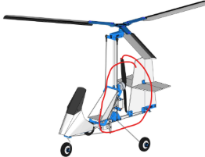

Compared to the Durafly and Thunderfly options, this Autogyro doesn't seem to have much room in the fuselage/body to mount other components (circled in red). It may be more difficult to modify (for eg to mount a camera) due its small form factor and compact nature. Additionally, this Autogyro has the main propeller on the rear which is not the ideal configuration of an Autogyro. As a result, the dynamics of the system may be different than expected.

Summary Table:

Points were assigned to each feature: +1 being an advantage, 0 being neutral, and - 1 being a disadvantage. N/A is where information was unavailable. (Fewer number of modifications = +1 since it saves the team time and resources towards achieving the final project requirements)

| Autogyro Option | Material To Be Modified | Fuselage Design | Waterproofing Requirements | Ease of mounting external components | Amount of Modifications Required | Extra Parts Availability | Total Points |
| --- | --- | --- | --- | --- | --- | --- | --- |
| Durafly Auto G2 V2 | +1 | +1 | +1 | +1 | -1 | +1 | +4 |
| Thunderfly TF-G2 | N/A | +1 | 0 | +1 | +1 | -1 | +2 |
| Rainbow Autogyro | N/A | 0 | N/A | N/A | -1 | 0 | -1 |
| RPG Autogyro V2 | -1 | -1 | -1 | 0 | 0 | N/A | -3 |
| MIA EZ Gyro 1.o | N/A | -1 | N/A | -1 | -1 | 0 | -3 |

Based on these results, the top choices are the Durafly Auto G2 V2 and the Thunderfly TF-G2. Both these options enable easy modifications which will directly address the goal of the project and save the team time and resources going forward.

How the ease of modification affects other aspects of the project:

The ease of modification affects what camera and control system hardware is chosen. Since such hardware has to be mounted onto the Autogyro via modifications, it is vital that the option chosen is easy to modify, has sufficient space both externally and internally in the fuselage, and enables smooth flight without too many alterations required. The size of the camera chosen for e.g, is related to the size of the Autogyro fuselage and if sufficient space is there to accommodate a certain sized camera.

Summary of Phone Calls:

As mentioned before, the company which manufactures the Thunderfly TF-G2 is located in the Czech Republic. Delivery times would be longer compared to the Durafly which ships from the United States. A phone call was made to +420 797 727 718 which is the contact number listed on ThunderFly's website. No response was received.

Conclusion:

All things considered, the Durafly Auto G2 V2 was purchased by the team. Going forward, the team will be testing and modifying the UAV as required to meet the desired application of the sponsor which is to monitor the wave conditions and sea life along the shoreline near Scripps pier.

References and Citations:

Durafly Auto G2 V2:

<https://hobbyking.com/en_us/durafly-pnf-auto-g2-v2-gyrocopter-w-auto-start-821mm.html?srsltid=AfmBOoqxMc6m3Lj8zJIH4LUS241nN8sFy0shjmE-t0ag4c0AdTVf3ZzD>

Thunderfly TF-G2:

<https://www.thunderfly.cz/tf-g2.html>

Rainbow Autogyro:

<https://icare-icarus.3dcartstores.com/Rainbow-Autogyro_p_432.html>

RPG Autogyro V2:

[https://www.sarikhobbies.com/product/rpg-Autogyro-v2-short-kit/](https://www.sarikhobbies.com/product/rpg-autogyro-v2-short-kit/)

MIA EZ Gyro 1.o

[http://www.micro-flight.com/mia_ez_gyro_1_0_rc_Autogyro.html](http://www.micro-flight.com/mia_ez_gyro_1_0_rc_autogyro.html)

Wind Speed Data for Scripps Pier:

<https://www.surf-forecast.com/breaks/Scripps-Pier/wind-stats>

## Appendix B: Individual Component Analysis: Camera and Streaming System (Ruochen Li)

**Project Description:**

The UAV Autogyro project focuses on designing, building and testing a UAV that uses Autogyro technology for enhanced stability and safety and efficient aerial monitoring over coastal waters. An Autogyro UAV, unlike traditional quadcopters and octocopters that rely entirely on powered rotors for lift, an Autogyro UAV uses an unpowered rotor to produce lift through autorotation, and the forward thrust is provided by an engine-driven propeller. This configuration allows for controlled descent even in case of power failure, making it a reliable choice for long-duration monitoring over the ocean. The primary goal is to use this UAV for real-time video streaming of sea conditions.

**Fundamental Requirements**

To achieve effective real-time monitoring, the UAV must be equipped with a high-resolution camera and a reliable streaming system that ensures uninterrupted video transmission over coastal water. Since the Autogyro will be high up in the air, the camera should be able to capture clear high-resolution footage, minimum 1080p and preferably 4K, to ensure accurate sea condition monitoring. The camera should support wide-angle or adjustable field-of-view capabilities for comprehensive coastal monitoring. In case of adjustable field-of-view capabilities, a rotatable, light-weighted and erosion resistant camera could be used. The camera must have stabilization features to reduce motion blur caused by UAV movement. For the real-time video streaming, the system must enable low-latency streaming to a ground for real-time observation of sea conditions. It should support multiple streaming resolutions to adapt to bandwidth limitations and ensure smooth transmission. It should integrate reliable video encoding for efficient data compression and transmission. The transmission system must be robust to send video data without significant interruptions. The camera and transmission module must operate within the UAV’s power constraints, optimizing battery life for extended flight missions. The camera and transmission system must be resistant to moisture, wind, and varying lighting conditions for reliable outdoor operation. The equipment should be lightweight to minimize impact on UAV performance while maintaining durability.

**Options**

Video Streaming Methods

4G/5G Streaming: Allows the UAV to directly transmit live footage to a remote server or monitoring station via a cellular network. This method provides real-time access but may suffer from connectivity issues over open water, depending on network coverage.

Ground-Based Antenna Transmission: Uses a dedicated receiver on land to receive and stabilize the video feed over longer distances. This method reduces transmission lag and ensures more reliable data reception, especially in remote areas where cellular networks may be unstable.

Onboard Recording: Stores video footage on an SD card, eliminating connectivity concerns but preventing real-time analysis. This option is useful for post-mission data review and can serve as a backup if live streaming fails.

Camera and Streaming System Options:

DJI O4 Air Unit: A compact and lightweight 4K FPV camera with low-latency transmission, making it ideal for real-time monitoring. It provides a stable and clear video feed but requires a DJI video receiver for long-range operation. The air unit integrates a video encoder and antenna, making it a self-contained streaming solution. However, it only supports ground-based antenna transmission and does not have built-in support for 4G/5G streaming or onboard recording.

GoPro Hero: Capable of high-resolution recording (5312×2988) with built-in stabilization, this camera delivers excellent image quality. However, it requires an external power source for extended use and does not support native real-time streaming. A microcomputer (such as a Raspberry Pi) is required for video encoding, and an additional antenna is necessary for transmission. This setup allows the GoPro Hero to support 4G/5G streaming, ground-based antenna transmission, and onboard recording.

ESP32 Cam: A low-cost alternative with lower resolution (1600×1200) but minimal power consumption (1.5W). While not ideal for high-definition streaming, it is suitable for basic video capture and lightweight UAV applications. A microcontroller (such as an Arduino) is required for video encoding, and an additional antenna is necessary for transmission. This setup enables the ESP32 Cam to support both 4G/5G streaming and ground-based antenna transmission, but it does not support onboard recording by itself.

**Summary**

Video Streaming Methods

| **Method** | **Pros** | **Cons** |
| --- | --- | --- |
| **4G/5G Streaming** | - Real-time video transmission  - Accessible from remote locations | - Dependent on network coverage  - Connectivity issues over open water |
| **Ground-Based Antenna** | - Stable and reliable over long distances  - Less susceptible to network failures | - Requires a dedicated receiver on land  - More complex setup than 4G/5G streaming |
| **Onboard Recording** | - No connectivity issues  - High-quality footage for post-mission analysis | - No real-time monitoring  - Limited by onboard storage capacity |

Camera and Streaming System Options

| **Camera** | **Pros** | **Cons** |
| --- | --- | --- |
| **DJI O4 Air Unit** | - Low-latency 4K video  - Self-contained streaming system  - Stable video feed | - Requires a DJI receiver  - Only supports ground-based antenna transmission |
| **GoPro Hero** | - High-resolution recording (5312×2988)  - Built-in stabilization | - Needs external power source  - Requires additional components for streaming |
| **ESP32 Cam** | - Low power consumption (1.5W)  - Cost-effective | - Low resolution (1600×1200)  - Requires extra components for streaming and recording |

**FCC Regulations, Certification, and Licensing for UAV Video Transmission**

Compliance with Federal Communications Commission (FCC) regulations is essential when operating UAV video streaming systems to ensure legal transmission and prevent interference with other communication networks. The FCC enforces strict guidelines on the use of wireless frequencies, particularly in the 2.4 GHz and 5.8 GHz bands, which are commonly used for UAV video feeds. Any device that transmits over these frequencies must be FCC-certified, ensuring that it operates within approved power limits and does not cause harmful interference.

For standard consumer drones, FCC certification is typically pre-approved; however, modifications such as adding high-gain antennas or increasing transmission power may exceed the legal limits and require additional regulatory approval. Operators using ground-based antennas or custom-built transmission setups (e.g., integrating a GoPro with a Raspberry Pi for streaming) may need a HAM (Amateur Radio) license under FCC Part 97 regulations. A Technician-class HAM license is required for high-power transmissions beyond unlicensed limits and involves passing an examination on radio communication principles and safety.

Failure to comply with FCC regulations can result in legal consequences, including fines, confiscation of equipment, or operational restrictions. Therefore, UAV operators must ensure that all transmission equipment is FCC-certified and used within legally permitted parameters. When in doubt, verifying compliance with FCC guidelines before deployment is recommended to avoid potential regulatory issues.

References:

*Esp32 Series*, www.espressif.com/sites/default/files/documentation/esp32_datasheet_en.pdf. Accessed 14 Mar. 2025.

*Hero Specs*, gopro.com/en/us/shop/cameras/learn/hero/CHDHF-131-master.html?tab=tech-specs. Accessed 14 Mar. 2025.

“DJI O4 Air Unit Series - Specs - Dji.” DJI Official, [www.dji.com/o4-air-unit/specs. Accessed 14 Mar. 2025](http://www.dji.com/o4-air-unit/specs.%20Accessed%2014%20Mar.%202025).

“The Federal Register.” *Federal Register :: Request Access*, www.ecfr.gov/current/title-47/chapter-I/subchapter-A/part-15. Accessed 14 Mar. 2025.

“The Federal Register.” *Federal Register :: Request Access*, www.ecfr.gov/current/title-47/chapter-I/subchapter-D/part-97. Accessed 14 Mar. 2025.

Keywords:

UAV Streaming, Long-range drone video transmission options, FPV module, UAV Camera

## 

## 

## Appendix C: Individual Component Analysis - Flight Controller (Pranav Sakhuja)

**Project Overview and Component Background**

Autogyro UAVs are aircraft that can be classified as a hybrid between fixed wing planes and helicopters due to the use of the front driving propeller paired with the lift generating stabilizing rotor on top. The objective of this project is to develop an Autogyro aircraft that is capable of monitoring the Scripps Pier and surrounding waters to live stream video footage of wave conditions and possible shark sightings. The UAV must be capable of autonomous flight after take-off which must be planned through waypoints set on the Ground Control System.

The objective of this ICA is to conduct a market research and available flight controllers and associated firmware control software to allow for this autonomous navigation of the aircraft.

**Functional Requirements**

1. The aircraft consists of 5 degrees of controllable motion. These include Pitch, Yaw, Roll, Throttle and Starter (Initial Rotor Push while take off). Hence, the controller must have at least 5 channels.
2. The aircraft has an estimated maximum payload capacity of 760 grams based on dynamics simulations. Hence, the overall control system must not weigh more than 100 grams, to allow sufficient room for battery and camera system.
3. The controller must be compatible with manual takeoff and landing mode using a hand-held transmitter controller. The United States only allows the use of 915 MHz and 2.4GHz out of the commonly used hobbyist drone/aircraft frequencies. Hence, the telemetry radio must be affixed to this frequency.
4. The flight controller must have support for open sourced flight control firmware software stacks, specifically Ardupilot and PX4. Furthermore, support for communication protocols such as MAVLink and ROS would be highly desirable.

**Description**

Based on the functional requirements, several options of autopilot compatible flight controllers were researched and explored. The architecture of the control system would include the flight controller, GPS, SiK Telemetry Radio in addition to the battery and motors/servos/ESC setup (this was included with the Autogyro kit).

The chosen controller will need to be flashed with a flight control firmware software stack. This stack should be responsible for setting waypoints on the Ground Control Software (GCS) prior to the flight for path planning, help monitor telemetry and sensor data and also in future integrate with the camera streaming feed. The 2 major software stacks include:

1. **ArduPilot**: A hobbyist oriented open-source project with a longer history than almost any other control firmware for hobbyist UAV development. Ardupilot is a monolithic stack, meaning it is more plug and play with less modularity. Furthermore, it has support for IMU redundancy.
2. **PX4**: A more research focused open-source software stack with great documentation, with good support and community. This is more in the active development and improvement stage. PX4 is a highly modular stack which allows for better communication and integration with experimental setups – like integration of custom AI and communication protocols

Both of the above mentioned software stacks are good, but have only “experimental” stable support for Autogyros. Hence, it will take more trial-and-error to explore their strengths and weaknesses.

For the controller hardware, a controller that can run BOTH of the above mentioned stacks is needed. Following are 3 options that were considered:

1. **Holybro Pixhawk 6C Mini:** High performance H7 processor with 480 MHz clock speed paired with redundant dual Bosch IMUs, vibration isolation and very well established accessories and peripherals including GPS, 915MHz antenna etc. 8 PWM outputs. 40g and USD 158. Also mini size has great weight and dimensions for those limitations on board the fuselage.
2. **Cube Orange:** STM32 @ 400MHz fit with triple IMUs for redundancy and vibration isolation. Provides support for CANbus telemetry unlike other controllers here. 8 PWM outputs with room for expansion. Recommended using ArduPilot over PX4. Higher weight and price. 80g and USD 385
3. **Matek H743-Wing:** STM32 @ 480 MHz. It has a single IMU so no redundancy and also no support for vibration isolation. 8 channels. Recommends using ArduPilot or iNav. Limited documentation and no records with Autogyros.

Based on the above analysis, the **Holybro Pixhawk 6C Mini** is the best balance with features, requirement fulfilment and cost.

**Summary of Component Selection:**

| **Controller** | **Pros** | **Cons** | **Cost** | **Shipping Est.** |
| --- | --- | --- | --- | --- |
| **Pixhawk 6C Mini** | Dual IMUs, vibration isolation, lightweight (40g), supports PX4 & ArduPilot, good documentation. Great peripheral compatibility | No CANbus telemetry, fewer expansion options. | $163   |  | | --- | | ~2 weeks |
| **Cube Orange** | Triple IMUs (best redundancy), CANbus telemetry, expandable, vibration isolation. | Expensive, heavy (80g), best with ArduPilot (PX4 less optimized). | $499   |  | | --- | | 1-2 weeks |
| **Matek H743-Wing** | Cheap, lightweight (35g), supports ArduPilot/iNav. | No IMU redundancy, no vibration isolation, limited Autogyro documentation.   |  | | --- |  |  | | --- | | $90   |  | | --- | | 1 week |

**Effect on other aspects of Design:**

The prime effect the choice of controller would have on the project’s design aspects would be the interior fuselage design. As of 03/13/2025, the Autogyro kit being used in the risk reduction has the interior fuselage space to just fit a small 3 cell battery, a receiver module and an ESC. Since there is not enough space in the interior of the fuselage for payload including the Flight controller, GPS, sensors, signals and power PCB etc, a new fuselage design that allows a much higher dimensional capacity would have to be designed and manufactured. Furthermore, the design would need to be such that the wires and cables are tucked away so the battery can be easily swappable. In addition, in case the risk reduction proves that the current Autogyro kit can not lift off with at least 250 grams of payload, more weight reduction and rotor modification would be required to increase the payload capacity to accommodate all the hardware necessary for a planned autonomous flight as desired.

**References and Information Sources:**

**Websites**

* ArduPilot Documentation (<https://ardupilot.org/plane/docs/common-autopilots.html>)
  + Provided a big list of compatible controllers with brief descriptions
* PX4 Developer Guide ([px4.io](http://px4.io))
  + [https://docs.px4.io/main/en/frames_Autogyro/index.html](https://docs.px4.io/main/en/frames_autogyro/index.html)
* Holybro Pixhawk 6C Mini Product Page (<https://holybro.com/products/pixhawk-6c-mini?variant=44511517475005>)
* ProfiCNC Cube Orange Product Page (<https://ardupilot.org/copter/docs/common-thecubeorange-overview.html>)

**Forums:**

* Dronecode Foundation (From PX4 website) Discord Community (ID 1022170275984457759)
  + Communicated with other Autogyro users here about integration and sensor setup
* <https://github.com/PX4/PX4-Autopilot/issues>

**Communications:**

* I attempted to call Holybro (Manufacturer of Pixhawk 6C Mini) and CubePilot manufacturers but only a contact form was available. No phone numbers seem to be available for general inquiries.
* I contacted Triton UAS, the student organization that engineers UAVs equipped with these systems and had discussions on requirements and specifications with them. Also, I worked with them to finalize my controls architecture and am currently working on the signals/sensors board design.

## Appendix D: Individual Component Analysis - Payload Capacity of Autogyros (Aaditya Shivadey)

**Project Description - UAV Autogyro**

UAV Autogyro is a project affiliated with Professor Robert Heath in the ECE department that is aimed at developing an autonomous Autogyro that is capable of flying along the coastal areas of La Jolla to look for sharks and monitor the ocean waves. The primary reason for using an Autogyro to accomplish this task is to try to mitigate the risks associated with using VTOL drones in the case of a motor failure. An Autogyro produces forward motion through the use of the forward propeller that is powered by a BLDC. This forward motion and the flow of the air over the rotor blades on top of the Autogyro enables it to generate lift. Since this rotor is unpowered and relies on the forward inertia of the Autogyro, it is more redundant in comparison to VTOL drones since it can enable a more controlled descent in the case of the failure of the front propeller.

The team decided that instead of fully designing an Autogyro, purchasing an off-the-shelf kit and modifying to fit the project’s needs was the most time efficient approach. The purchased Autogyro will then be modified according to the needs of the project. Live streaming of the flight and autonomous capabilities will also be implemented. To enable this, the Autogyro will need to carry a payload consisting of the camera module, antennas, telemetry reader, and the autopilot computer.

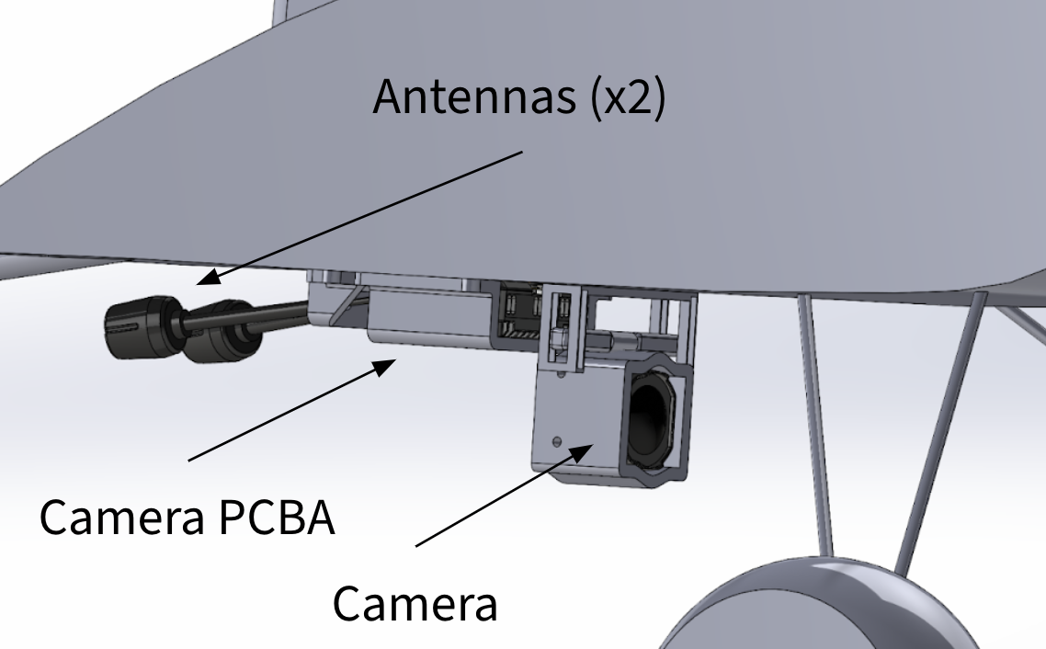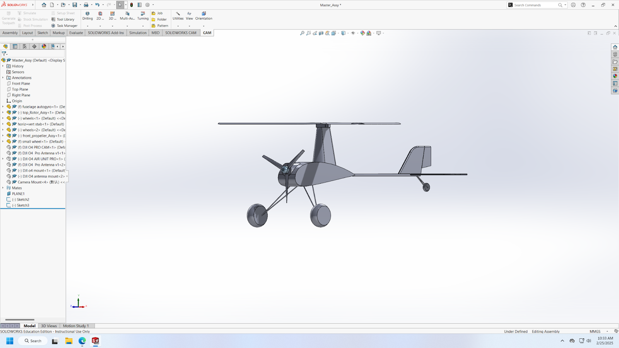

Autogyro CAD External Payload on Autogyro

**Functional Requirements of ICA - Payload Capacity of Autogyros**

This report will be focussed on looking at off-the-shelf Autogyro kits and comparing their payload capacity to select the kit that best fits with the functional requirements of the project. The payload capacities of the Autogyros were simulated using a Matlab script developed by the team specifically for this project. The script took in variables such as rotor diameter, airfoil shape and lift coefficient, Autogyro weight, flight speed, Autogyro drag coefficient, wind conditions, and flight altitude. The functional requirements are as follows:

* Autogyro must be capable of carrying a payload of at least 300g
* Autogyro’s fuselage must have enough space for housing/mounting the payload
* Material of the fuselage should be able to support the payload
* Autogyro must have at least 3 radio functions for control
* Autogyro should be easily available to order in case of damage during testing

**Description of 3 Different Components:**

1. **Durafly Auto-G2 V2 (Price: $139.99) [1]:**

This is one of the most popular commercial off-the-shelf Autogyro that is widely used by hobbyists. It’s 795mm long, 392mm in height, and has a rotor diameter of 821mm. It has 5 channels for radio control (roll, pitch, yaw, front motor, and rotor start). The fuselage and the stabilisers are made up of EPO foam, making them lightweight, water resistant, and durable. The simulated payload capacity of the Durafly Auto-G2 V2 is 767g.

1. **RPG Autogyro V2 (Price: $156.18) [2]:**

This is another commercial off-the-shelf Autogyro used by hobbyists primarily in the United Kingdom. Out of all other Autogyros analyzed, this one has the largest rotor diameter – measuring 1.2 meters. This Autogyro just has 3 radio functions (pitch, yaw, and front motor). The fuselage and other body components are made up of wood, making it lightweight but not suitable for flying in high humidity/foggy flying conditions. The simulated payload capacity of the RPG Autogyro V2 is 2,230g.

1. **MIA EZ Gyro 1.0 (Price: $159.99) [3]:**

The MIA EZ Gyro 1.0 is als another popular and easy to use commercial off-the-shelf Autogyro by hobbyists. Out of all the other Autogyros, this one has the smallest rotor diameter, measuring just 609mm. Just like the RPG Autogyro, the MIA EZ Gyro also just has 3 radio functions (pitch, yaw, and front motor). Its rotor is made up of wood while its main fuselage is primarily made up of polypropylene. The simulated payload capacity of the MIA EZ Gyro 1.0 is 386g.

**Summary of Pros and Cons:**

| Name of Autogyro | Pros | Cons |
| --- | --- | --- |
| Durafly Auto-G2 V2 (Price: $139.99)  (Shipping time: 2-6 days) | - It is the cheapest Autogyro.  - Has the most accessible technical specification sheet.  - Great handling and flying characteristics (from pilot reviews). | - Foam rotors are susceptible to damage.  - Autogyro kit is challenging to assemble. |
| RPG Autogyro V2 (Price: $156.18)  (Shipping time: 7-14 days) | - Has the largest payload capacity.  - Wood rotors provide rigidity. | - Small landing gears reduce its overall rigidity and make landings difficult.  - 1.2 meter diameter rotor makes transportation and storage challenging. |
| MIA EZ Gyro 1.0 (Price: $159.99)  (Shipping time: 5-10 days) | - Small and easy to transport  - Autogyro kit is easy to assemble. | - Has the smallest rotor and hence the smallest payload capacity.  - Challenging flight characteristics (from pilot reviews). |

After conducting the market research on the Autogyros and after careful analysis of the pros and cons, the Durafly Auto-G2 V2 appears to be the strongest option. Although it doesn’t have the highest payload capacity, its rotor size can be increased to enable it to carry a higher payload. The primary reason for its choice was due to it having a higher number of radio control channels and also due to its relative ease of payload integration. In addition to that, its low price and easy access to spare parts make it the ideal choice for this project.

**Description of Effect of Autogyro Choice on Other Aspects of Project:**

Since the Durafly Auto-G2 V2 is the strongest option out of all the other Autogyros that were analysed, it is important to understand how selecting this will affect other aspects of the project. The other primary aspects of the project include autonomous control integration, camera and live streaming integration, and ease of modification. The main components that would be required to be integrated with the Autogyro to enable autonomous control integration are the flight controller and the telemetry antennas. The relatively hollow interior of the fuselage of the Durafly Auto-G2 V2 enables the flight controller to be easily integrated. In addition to that, the large flat underbody enables easy mounting of the antennas. This also enables the camera to be mounted with ease.

Another equally important aspect of the project is the ease of modification of the Autogyro. It is important for the selected Autogyro to be easily modified to meet the unique needs of the project. The relatively long tail boom and modular construction of the Durafly Auto-G2 V2 enables new components to be easily added to the fuselage without the need for a major redesign. To increase stability in high wind conditions, a lift device such as a wing can be mounted to the long tail boom. In addition to that, the modular construction of the Autogyro enables the off-the-shelf parts to be replaced with customized 3D prints–improving strength resistance and reducing weight.

**References:**

Phone Call:

1. Company: Sarik Hobbies

Email: [info@ssarikhobbies.com](mailto:info@ssarikhobbies.com)

Phone: +44 (0)1684 311682

Description of Call: The call began with a chat with the sales representative who spoke to me about the specifications of the RPG Autogyro V2. Then, the representative directed me to an applications engineer who was also a pilot who spoke to me about the ease of assembly and flight characteristics of the Autogyro.

Appendix:

[1] “Durafly (PNF) Auto-G2 V2 Gyrocopter w/Auto-Start 821mm,” Hobbyking, 2025. https://hobbyking.com/en_us/durafly-pnf-auto-g2-v2-gyrocopter-w-auto-start-821mm.html?srsltid=AfmBOorZre9a6th7DbkNRZSTZXx6YBj5Imsyh9K19YCTyd-OEfw8kCQS (accessed Mar. 13, 2025).

[2]“RPG Autogyro V2 - Short Kit (Set) - Sarik Hobbies - for the Model Builder,” Sarik Hobbies - for the Model Builder, Dec. 19, 2024. https://www.sarikhobbies.com/product/rpg-Autogyro-v2-short-kit/ (accessed Mar. 13, 2025).

[3]“MIA EZ™ Gyro 1.0 RC Autogyro kit,” Micro-flight.com, 2025. http://www.micro-flight.com/mia_ez_gyro_1_0_rc_Autogyro.html (accessed Mar. 13, 2025).

## Appendix E: Flight Log

## 

## Code Used

**Object Detection and Gimbal Control Script (object_detection_control.py)**

This script implements real-time person detection using YOLOv8n and controls a dual-axis gimbal (FS90R for pan, MG90S for tilt) via serial commands. The system uses a sigmoid-based PID controller for smooth tracking.

| import cv2 import numpy as np import time import serial from ultralytics import YOLO  # ----- Pan Servo Control ----- class PanController:  def __init__(self, base_speed=92, min_speed=60, max_speed=120):  self.base_speed = base_speed  self.min_speed = min_speed  self.max_speed = max_speed  self.last_error = 0  self.integral = 0   def sigmoid_pid(self, error, Ki=0.005, Kd=0.01, dt=0.1, max_output=10):  derivative = (error - self.last_error) / dt  p_term = 6 * (1 / (1 + np.exp(-error / 40)) - 0.5)  output = p_term + Ki * self.integral + Kd * derivative  output = np.clip(output, -max_output, max_output)  self.integral += error * dt  self.last_error = error  return int(np.clip(self.base_speed + output, self.min_speed, self.max_speed))  # ----- Tilt Servo Control ----- class TiltController:  def __init__(self, angle=90, min_angle=60, max_angle=120):  self.angle = angle  self.min_angle = min_angle  self.max_angle = max_angle  self.last_error = 0  self.integral = 0   def sigmoid_pid(self, error, Ki=0.005, Kd=0.01, dt=0.1, max_output=4):  derivative = (error - self.last_error) / dt  p_term = 6 * (1 / (1 + np.exp(-error / 40)) - 0.5)  output = p_term + Ki * self.integral + Kd * derivative  output = np.clip(output, -max_output, max_output)  self.integral += error * dt  self.last_error = error  self.angle += output  self.angle = np.clip(self.angle, self.min_angle, self.max_angle)  return int(self.angle)  # ----- Object Detection ----- def videoCapture(cam_num=1):  cap = cv2.VideoCapture(cam_num, cv2.CAP_DSHOW)  cap.set(3, 320)  cap.set(4, 240)  time.sleep(1)  return cap  def object_detection(frame, model, min_conf=0.8):  results = model(frame)[0]  centers = [(int((x1 + x2) / 2), int((y1 + y2) / 2))  for x1, y1, x2, y2, conf, cls in results.boxes.data.tolist()  if int(cls) == 0 and conf >= min_conf]  if centers:  x_obj, y_obj = map(int, np.mean(centers, axis=0))  return x_obj, y_obj  return None, None  # ----- Main Loop ----- if __name__ == "__main__":  model = YOLO("yolov8n.pt")  pan_ctrl = PanController()  tilt_ctrl = TiltController()  ser = serial.Serial("COM17", 9600, timeout=1)  cap = videoCapture()  frame_id = 0   while True:  ret, frame = cap.read()  if not ret:  continue   x_obj, y_obj = object_detection(frame, model)  h, w = frame.shape[:2]  cx, cy = w // 2, h // 2   if x_obj is not None:  dx = -(x_obj - cx)  dy = y_obj - cy  dx = np.clip(dx, -100, 100)  dy = np.clip(dy, -100, 100)   pan = pan_ctrl.sigmoid_pid(dx)  tilt = tilt_ctrl.sigmoid_pid(dy)   if frame_id % 2 == 0:  ser.write(f"P{pan}T{tilt}\n".encode())   cv2.drawMarker(frame, (cx, cy), (255, 0, 255), cv2.MARKER_CROSS, 20, 2)  cv2.circle(frame, (x_obj, y_obj), 5, (0, 255, 0), -1)  cv2.imshow("Tracking", frame)  if cv2.waitKey(1) & 0xFF == ord('q'):  break  frame_id += 1   cap.release()  ser.close()  cv2.destroyAllWindows() |
| --- |

**Arduino Gimbal Servo Control Script (cam_control.ino)**

This Arduino sketch receives serial commands in the format P<pan_angle>T<tilt_angle>\n and adjusts the corresponding servos accordingly. It is used to interface with the object detection system described in Appendix

| #include <Servo.h>  Servo panServo; Servo tiltServo;  void setup() {  Serial.begin(9600);  panServo.attach(9); // Pan servo on pin 9  tiltServo.attach(10); // Tilt servo on pin 10 }  void loop() {  if (Serial.available()) {  String cmd = Serial.readStringUntil('\n'); // Read full command line  int pIndex = cmd.indexOf('P');  int tIndex = cmd.indexOf('T');   if (pIndex != -1 && tIndex != -1 && tIndex > pIndex) {  int pan = cmd.substring(pIndex + 1, tIndex).toInt();  int tilt = cmd.substring(tIndex + 1).toInt();   // Constrain and write to servo  pan = constrain(pan, 60, 120);  tilt = constrain(tilt, 60, 120);   panServo.write(pan);  tiltServo.write(tilt);  }  } } |
| --- |

## Project Management

### **Task Distribution**

* Aaditya - Mechanical Design and Manufacturing
* Arham - Mechanical Design and Manufacturing
* Ruochen - Camera setup, streaming and computer vision
* Pranav - Control system design and electronics harness

### **Risk Reduction Effort**

The main goal of the risk reduction effort was to identify the maximum transportable mass of the Durafly Auto G2 V2. 10 gram mass disks were purchased and a custom carrying box was designed and 3D printed. The mass disks could be placed and removed within slots in the box to vary the total mass of the box. These mass boxes were then mounted onto the bottom of the autogyro and test flights were conducted. The results of the risk reduction was that the autogyro was able to successfully takeoff and fly with an additional payload of 270 grams.

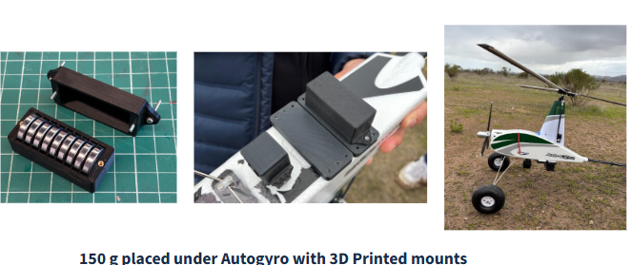

270 gram Payload Risk Reduction Flight

### **Intermediate deadlines**

The following were the intermediate deadlines the team worked towards in order to achieve the overall goals of the project:

1. Risk reduction (Winter quarter, week 10): This test was essential to determine the maximum payload capacity of the autogyro and to verify if it would be able to fly with the electronics necessary to enable autonomy.
2. Fuselage proof of concept (Spring quarter, week 4): The team had to determine the optimum size, material, and manufacturing procedure for the enlarged fuselage so that manufacturing and testing can be accomplished.
3. Electronics system setup and integration (Spring quarter, week 4): The electronics suite necessary to enable autonomy had to be finalized and all the systems had to be integrated and tested to verify functionality.
4. Manual flight testing with enlarged fuselage (Spring quarter, week 6): Flight testing with enlarged fuselage had to be completed to understand the impact it had on the flying characteristics of the autogyro and make any required changes if necessary.
5. Manual flight testing with finalized fuselage (Spring quarter, weeks 8-10): The team had to conduct multiple flights with the finalized fuselage along with the full payload to collect data, rectify issues, and meet the project objectives.

### **Layouts**

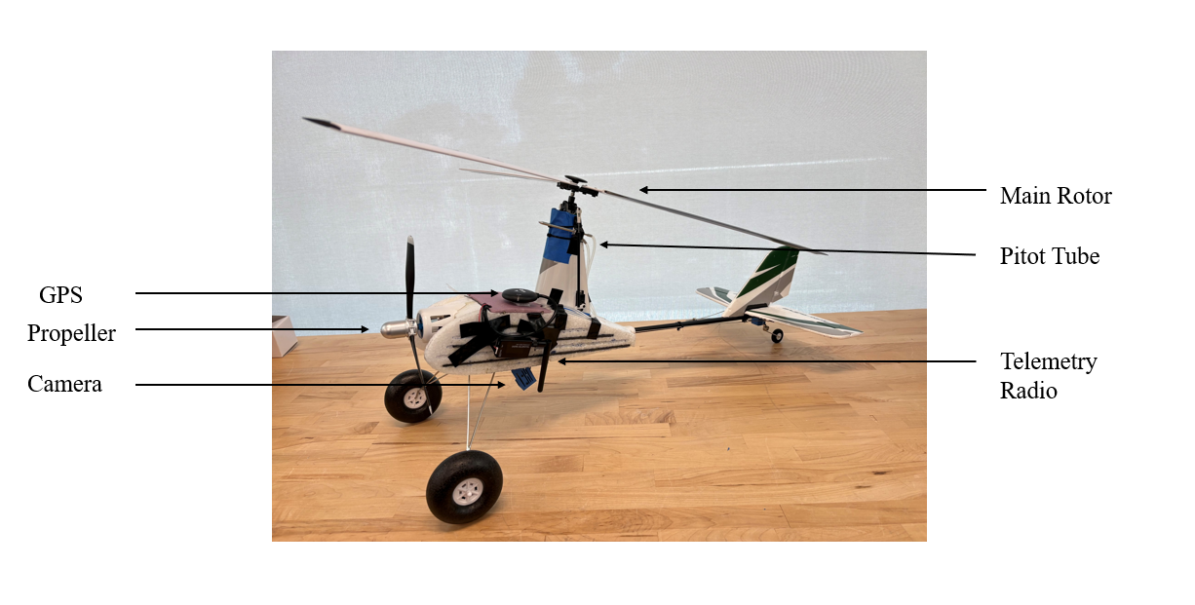

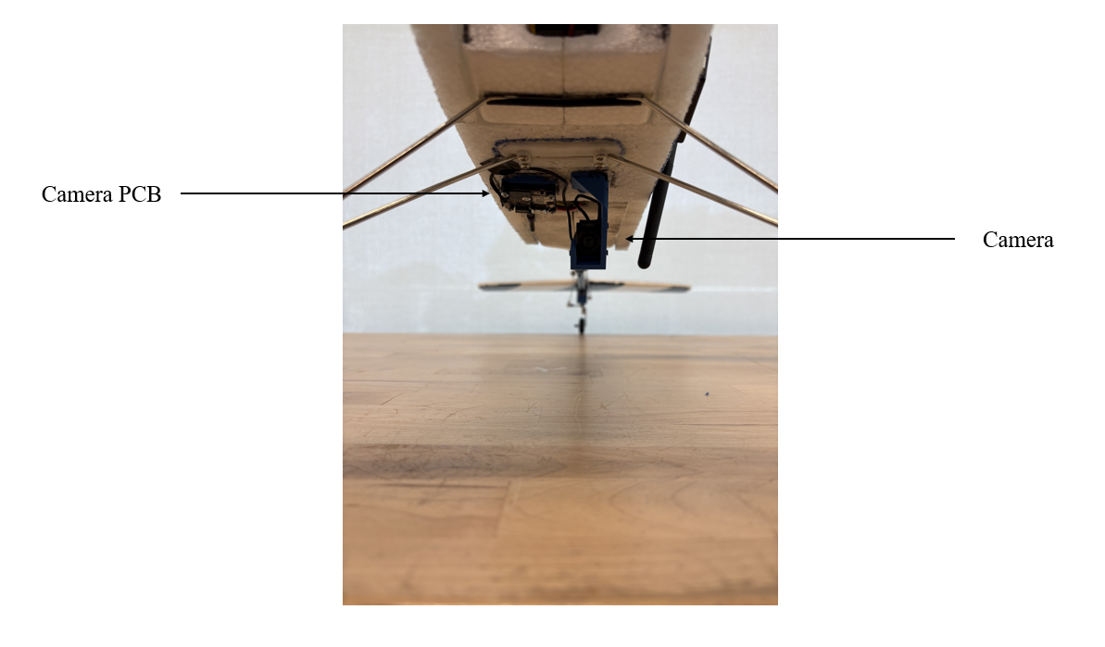

### **List of Suppliers / Purchased Part Information**

Part List:

* DJI
  + DJI O4 Air Unit
  + DJI Goggle N3
* Radiolink：
  + Radiolink Divit Digital Video Transmission Adapter Board
* Holybro
  + Pixhawk 6c Mini Model A
  + M10 GPS Module
  + PM06 Power Module
  + Digital Air Speed Sensor - MS4525DO with Pitot Tube
  + SiK Telemetry Radio V3
* Updated Fuselage

* + Durafly Auto G2 V2 Base Kit
  + Fielect - 3mm Carbon Fiber Rods
  + Expanded Polypropylene Foam (EPP foam)
  + Bob Smith - 5 minute Quick Cure Epoxy
  + Rhinocats Tiny Magnet Set

### **Budget**

| Item | Cost (Including Tax) |
| --- | --- |
| Durafly (PNF) Auto-G2 V2 Gyrocopter w/Auto-Start 821mm | $149.99 |
| Durafly Auto-G2 V2 Gyrocopter Replacement Main Blades w/Decals (3pcs) | $25.52 |
| Replacement Parts | $43.48 |
| Durafly (PNF) Auto-G2 V2 Gyrocopter w/Auto-Start 821mm | $154.99 |
| Replacement Rotors and Pushrod Connectors | $40.47 |
| Replacement Fuselage and Autostart switch | $42.32 |
| 1. Durafly (PNF) Auto-G2 V2 Gyrocopter w/Auto-Start 821mm  2. Autostart motor and assembly  3. Rotor Tower Assembly | $178.81 |
| Front propeller motor | $29.98 |
| 1. Replacement fuselage  2. Front propeller motor  3. Front propeller baldes  4. Rotor blades  5. Autostart switch  6. Rotor tower assembly | $87.57 |
| 1. DJI O4 Air Unit  2. DJI Goggles N3 | $367.58 |
| 1. Pixhawk 6C Mini Model A Flight Controller  2. SiK Telemetry Radio V3 500mW 915MHz | $279.64 |
| 1. Alaohu Flysky FS-i6X 10 Channels RC Transmitter and Receiver  2. TATTU LiPo Battery Pack 1300mAh 45C 3S 11.1V with XT60 Plug(2 Pcs) | $101.25 |
| Bambu PLA Aero | $55.47 |
| FLY RC 2Pack XT60 Male Connector Plug to 4mm Banana Plugs Battery Charge Lead Adapter Cable | $8.61 |